**CS157B Final Report**

**Study on Database Technologies While Working with Yelp Data**

**By Frank Mock**

**Working with SQL using MySQL**



**Exploring Map Reduce with**

**Hadoop**

**Batch and Stream**

**Process Data with Spark**

**CouchDB - A NoSQL Document Store**

Table of Contents

Project Overview 3

Description 3

Data 3

Bird’s Eye View 3

SQL 4

Setup 4

Database / Schema 5

ETL 6

Retrieval Queries 7

Update Queries 10

Data Quality / Consistency 12

Performance Optimization 13

Hadoop Map Reduce 19

Setup 19

Database / Schema 20

ETL 21

Queries 24

Updates 33

Data Quality / Consistency 33

Performance Optimization 34

Spark 38

Setup 38

Database / Schema 39

ETL 39

Queries 41

Update 46

Data Quality / Consistency 46

Performance Optimization 47

NoSQL with CouchDB 58

Setup 59

Database / Schema 60

ETL 60

Queries 63

Update 68

Data Quality / Consistency 68

Performance Optimization 69

Technology Comparison 70

# Project Overview

## Description

This goal of this report is to describe various database technologies and discuss their strengths and limitations in the context of performing various OTLP and OLAP queries. With each database technology presented, I will start by describing the process of setting up the database. This will be followed by a description of the ETL (Extract, Transform, and Load) process. Various queries will give the reader an idea of how each database technology works. Often, I will make technology comparisons and describe how they relate to one and another. However, this paper concludes with a full comparison of each technology and my observations while working with each.

## Image result for yelpData

The dataset used while exploring each database technology was the Yelp dataset. This dataset is made freely available to anyone. To obtain the data, one can visit <https://www.yelp.com/dataset_challenge> to download it. However, I downloaded the data from the Google Drive setup for the CS157B class. These data were preferred since they were divided into logical sets. They were made available in the form of JSON files. These sets include – business, user, review, checkin, and tip. The business dataset includes data on the business that were reviewed on the Yelp website. It contained such fields as business_id, name, city, state, and many more. The user dataset included information about the users that made the reviews on Yelp. The review dataset includes the actual review data. It includes fields such as review_id, user_id, business_id, stars, data, and text. The text field is the actual review the user made about a business. Another interesting dataset is tip. Tip contains user tips about a business, for example – ‘Arrive early to avoid a wait’.

# Bird’s Eye View

MySQL was the first database technology I explored for this project. I was the most familiar with this technology, as I have used it before for both academic purposes and for my personal websites. MySQL is a relational database management system or RDBMS. It is an opensource database system that is very mature. As the name suggests, MySQL uses a variant of the SQL language. It is a very good database solution for processing transactional queries (OLTP), but leaves something to be desired for complex analytical queries (OLAP) if the data is huge. After MySQL, I ventured into the realm of ‘Big Data’ with Hadoop. I have never worked with a big data technology before so this was completely new to me. Using the Hadoop file system and their Java API, I batch processed data using Map and Reduce functions. After working with Hadoop, I learned why it is a better choice for OLAP versus using MySQL and I will explain this in detail in the Hadoop section to follow. Next, I learned the Spark big data technology. Spark is an open source technology by Apache. Like Hadoop Map Reduce, I used Spark to batch process historical data. However, additionally I used Spark to work with streaming a source of data. I learned that the batch processing capabilities of Hadoop and the streaming capabilities of Spark complement each other and are part of the big data lambda architecture. The final big data technology I explored was another open source technology by Apache. CouchDB is a document based database technology that uses a RESTful API. Since it is geared around internet based technology, not surprisingly, it uses JavaScript to process data that is stored in the database in the form of JSON files. Since CouchDB uses a schema-less design, it is very different than a RDBMS. CouchDB is the endpoint of the lambda architecture and works with ther pre-computed data that the bacth and speed layer provide for it. I will explain what I observed while using this technology and what I think of it’s very flexible way of doing things.

# SQL

## Setup

Setting up MySQL is easy. I am using a Windows machine, and on the official MySQL website, <https://www.mysql.com/>, there is an installer that can be downloaded and used to install MySQL database. During the install process, you can set up users and choose a password. The installer will also install other database tools such as MySQL workbench. I decided against using the MySQL Workbench since I didn’t want any of the nuances of using a GUI based tool to get in my way while I worked. To start MySQL database, enter the command **mysql -h <host name> -u <user name> -p** and press enter. Next you will be prompted for your password and MySQL will start.

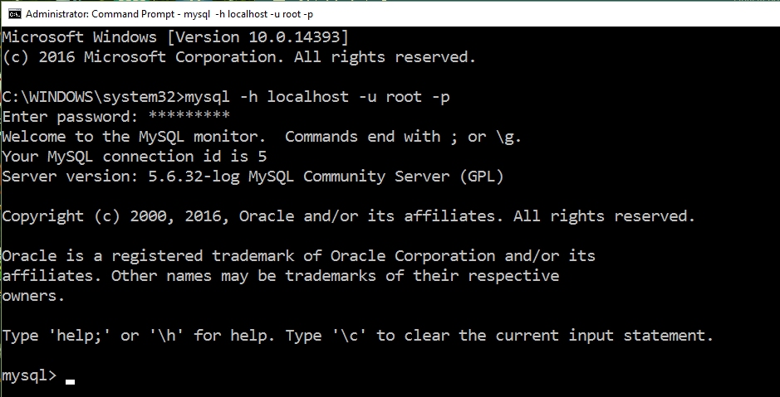

## Database / Schema

I created a SQL schema based on the JSON object data of the dataset that is provided when you download the Yelp dataset. I was able to infer the data types by reviewing this data and by reviewing a few lines of each JSON file. Most of the id’s where mixed characters and not integers so they were assigned the VARCHAR type. The information showed that almost all the datasets had a unique id, for instance the Business set had a business_id and the User set had a user_id field. In my schema design I made these fields primary keys so that MySQL can use these as indexes. The review dataset contained multiple id fields – review_id, user_id, business_id. Since the review_id field was unique I used this as a primary key and made the other two id’s foreign keys since they referenced primary keys in other tables. For this initial loading of the data I did not want to impose any further constraints on the data. The following is a sample of the schema that shows the meta-data of the review schema.

**DROP** **TABLE** **IF** **EXISTS** REVIEW**;**

**CREATE** **TABLE** REVIEW

**(**

review_id **VARCHAR(**30**),**

user_id **VARCHAR(**30**)** **REFERENCES** **USER(**user_id**),**

business_id **VARCHAR(**30**)** **REFERENCES** BUSINESS**(**business_id**),**

stars **INT,**

**date** **DATE,**

text **VARCHAR(**5010**),**

useful **INT,**

funny **INT,**

cool **INT,**

**type** **VARCHAR(**10**)**

**);**

## ETL

Even though MySQL has support for JSON files, I did not know how to import data in this form, but I did know how to import files that uses a character as a delimiter. I wrote a Java program to process the JSON files into character delimited files. I did not use commas as a delimiter since this would cause conflicts with the Yelp data. Instead, I used triple pipes as a delimiter.

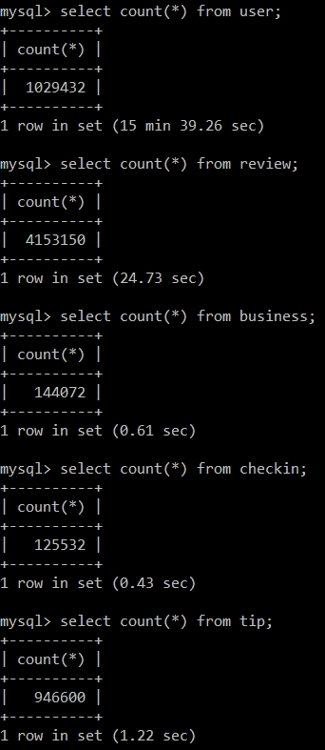

The SQL file that builds the schema also populates the tables with data. It uses the LOAD DATA LOCAL INFILE ‘<FILE-NAME>’ command. To inform MySQL that the data is delimited by triple pipe symbols, the script includes the command, COULUMNS TERMINATED BY ‘|||’. I ran the script using the MySQL command-line. It took well over an hour to load the data into the dataset! I started to think something went wrong, but it finished and had no errors. Next, I needed to check that all the data was loaded, so I counted the records in each set and checked to see that they matched the counts from the JSON files – it did. Successful import, the counts matched the JSON file counts. Note that it took MySQL over fifteen minutes to count the rows of the user table due to the number of records it contains.

## Retrieval Queries

My first query is an analytical query that involved the join of two tables and the aggregation function, Count. The time it took this query to complete was over a minute. The long running time of this query is likely directly proportional to the dataset size. It had to join two tables that contain a lot of data and then perform a mathematical operation on this data. If this query involved the user table it would have taken much longer since it contains millions of records. Even still, a query that takes over a minute in a real-world application would not be good. This type of query should be cached as a view if this data is needed often.

**Query #1**

**SELECT** business**.**business_id**,** name**,** **COUNT(**review**.**stars**)** **as** num_reviews

**FROM** business **JOIN** review **ON** business**.**business_id **=** review**.**business_id

**GROUP** **BY** business_id **Having** num_reviews **>** 1000 **ORDER** **BY** num_reviews**;**

+------------------------+---------------------------------------------+-------------+

| business_id | name | num_reviews |

+------------------------+---------------------------------------------+-------------+

| sNVGdeOPeitJ3OWUQBINzQ | BabyStacks Cafe | 1002 |

| IMLrj2klosTFvPRLv56cng | Honey Salt | 1005 |

| 4k3RlMAMd46DZ_JyZU0lMg | Ramen Sora | 1008 |

| IsoLzudHC50oJLiEWpwV-w | Chelsea's Kitchen | 1012 |

| gTlDDzDEHyDQ6iwjNhpI6A | Mount Everest India's Cuisine | 1016 |

| 0NmTwqYEQiKErDv4a55obg | Scarpetta | 1028 |

| OARQDsxyoGnnX2FfSl9HjA | Le Reve - The Dream | 1031 |

| q-zZgXKAQFLEgMp9ZNllgQ | Umiya Sushi | 1033 |

| NCFwm2-TDb-oBQ2medmYDg | Fountains of Bellagio | 1035 |

| 3N9U549Zse8UP-MwKZAjAQ | Liberty Market | 1036 |

| PVTfzxu7of57zo1jZwEzkg | FEZ | 1039 |

| EnCIojgP5KTr1leaysFE3A | Viva Las Arepas | 1045 |

| UUGoM4q4i8rK2CBRS0xDAw | Jean Philippe Patisserie | 1046 |

...

| El4FC8jcawUVgw_0EIcbaQ | MGM Grand Hotel | 3016 |

| AV6weBrZFFBfRGCbcRGO4g | Luxor Hotel and Casino Las Vegas | 3166 |

| iCQpiavjjPzJ5_3gPD5Ebg | Secret Pizza | 3258 |

| rcaPajgKOJC2vo_l3xa42A | Bouchon at the Venezia Tower | 3292 |

| SMPbvZLSMMb7KU76YNYMGg | ARIA Resort & Casino | 3385 |

| 5LNZ67Yw9RD6nf4_UhXOjw | The Cosmopolitan of Las Vegas | 3400 |

| KskYqH1Bi7Z_61pH6Om8pg | Lotus of Siam | 3458 |

| ujHiaprwCQ5ewziu0Vi9rw | The Buffet at Bellagio | 3482 |

| 2weQS-RnoOBhb1KsHKyoSQ | The Buffet | 3676 |

| f4x1YBxkLrZg652xt2KR5g | Hash House A Go Go | 3881 |

| eoHdUeQDNgQ6WYEnP2aiRw | Serendipity 3 | 3911 |

| hihud--QRriCYZw1zZvW4g | Gangnam Asian BBQ Dining | 4120 |

| DkYS3arLOhA8si5uUEmHOw | Earl of Sandwich | 4655 |

| cYwJA2A6I12KNkm2rtXd5g | Gordon Ramsay BurGR | 5116 |

| K7lWdNUhCbcnEvI0NhGewg | Wicked Spoon | 5216 |

| RESDUcs7fIiihp38-d6_6g | Bacchanal Buffet | 5715 |

| 4JNXUYY8wbaaDmk3BPzlWw | Mon Ami Gabi | 6414 |

+------------------------+---------------------------------------------+-------------+

177 rows in set (1 min 8.56 sec)

**Query #2**

**SELECT** **COUNT(DISTINCT** name**)** **FROM** **user;**

+----------------------+

| COUNT(DISTINCT name) |

+----------------------+

| 88722 |

+----------------------+

1 row in set (15 min 29.80 sec)

Query #2 simply counts the distinct names of the user table. The time it took for this query to run would be unacceptable for an on-demand or streaming web service. If this information was needed in such an app, it would need to be previously obtained and stored in a materialized view. Then the app could query the view and obtain the data much faster. With the queries thus far, it is becoming clear that MySQL may not be the best choice for big data.

In Query #3 I joined the user and review tables and the result took much longer. I believe that one reason for the additional time is that I joined the review table with the user table which is much larger than the business table of the first query. The result was the empty set. Over an hour just to get the empty set!

**Query #3**

**SELECT** review**.**user_id**,** name

**FROM** **user** **NATURAL** **JOIN** review **WHERE** review**.**text **LIKE** '%great%'**;**

Empty set (1 hour 29 min 24.24 sec)

When SQL has to join multiple tables with millions of records it is ridiculously slow. What made this query even slower was the fact that it had to search for something of which it had no index for. MySQL literally had to comb through every text entry of the join looking for the word ‘great’. When MySQL does not have and index to help with searches, it has no choice but to check record-by-record and word-by-word.

One thing I really like about SQL is how a query can include multiple subqueries. You can break a problem into multiple sub-problems and use the results of each sub-problem to solve the greater problem. The following query is a simple example that demonstrates this. It finds the users that have an average_star value that is greater than the average of all the users average_star values (names contained in the query result are not shown since there are over half million names in the result set).

**Query #4 (OLAP)**

**SELECT** name **FROM** **user** **WHERE** average_stars **>** **(SELECT** **avg(**average_stars**)** **FROM** **user);**

...

+----------------------------------+

583834 rows in set (21 min 45.07 sec)

## Update Queries

For a simple update, I choose to update a business that had an empty string for its neighborhood value and give it the value ‘The Ghetto’. The update took 0.12 seconds. Even though this seems fast, an insertion would likely be even faster. This is due to the fact that, a database has a pointer to the last element in a table, and for insertions, it simply writes to the next location. In contrast, an update must use its index table to locate the item to be updated and then it can write to the location.

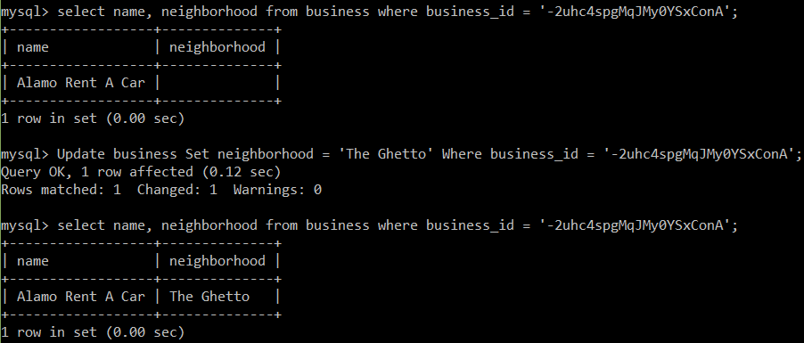

Next, I did a batch update. I updated the star value by .5 for every business named JCPenny in the business table.

**Update** business

**Set** stars **=** stars **+** .5

**Where** name **=** 'JCPenney'**;**

The update took approximately a quarter of a second, which is pretty fast. Internally, MySQL has a B-Tree of indexes which it uses to help improve the efficiency of queries. Since data is inherently normalized in a relational database and such a database has built-in support for indexes, update queries such as this example do not tax the database as much a one with a schema-free design would. The images that follow show the star count before and after the update.

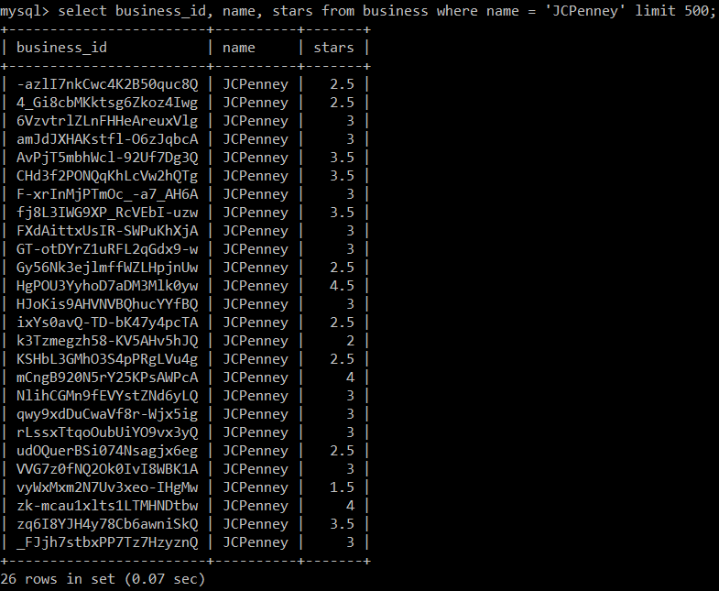

Above image shows the JCPenny star count before the batch update.

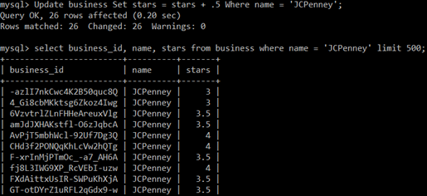

…

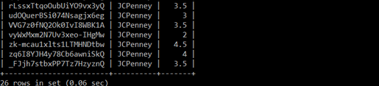

Above image shows the JCPenny star count after the batch update. <cropped image to fit page>

## Data Quality / Consistency

One way to improve my schema design that would help preserve data quality would be to add default values and attribute based constraints. For example, the review table has many fields that have a type of INT. It makes sense to give these fields an initial value of zero if there is no value inserted and since there is a default value it makes sense to add a NOT NULL check for each row. Since I didn’t want to re-load the data, I opted to Alter the existing table schema using the following command.

mysql**>** **ALTER** **TABLE** review **MODIFY** stars **INT** **NOT** **NULL** **DEFAULT** 0**;**

Query OK**,** 0 **rows** affected **(**18 **min** 38.60 sec**)**

Records**:** 0 Duplicates**:** 0 Warnings**:** 0

Since the star value is supposed to be an integer between zero and five, it makes sense to provide a range check for the values that try to be inserted. The SQL standard provides an attribute CHECK option that MySQL supports, by accepting it and ignoring it. So if you do the following MySQL will ignore it:

**ALTER TABLE review**

**ADD CHECK (stars < 5) 🡨 MySQL allows this but ignores it!**

Therefore, it was necessary to implement a trigger to check the value being assigned to the star attribute. I made a SQL file named star_check.sql with the following script. This trigger will reinforce data integrity by ensuring that if validation fails at the code level, the database level will stop the star value from becoming corrupt.

**DROP** **TRIGGER** **IF** **EXISTS** checkStarsTrigger**;**

**delimiter** **//**

**CREATE** **TRIGGER** checkStarsTrigger

**BEFORE** **INSERT** **ON** review

**FOR** **EACH** **ROW**

**BEGIN**

**IF** **NEW.**stars **>** 5 **or** **NEW.**stars **<** 0 **THEN**

**SET** **NEW.**stars **=** 0**;**

**END** **IF;**

**END;//**

**delimiter \;**

Similar other constraints can be added to the Yelp dataset to help preserve data integrity.

MySQL is very good at producing reliable results even with many concurrent operations being performed on a dataset. MySQL version 5.6, the version I am using on my machine, uses the InnoDB storage engine by default. The default transaction level for InnoDB is Repeatable-Read. I checked this by checking the isolation level of the user table.

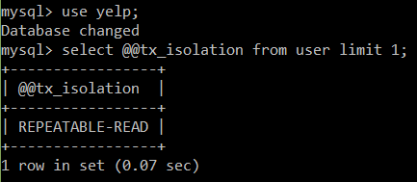

With this isolation level MySQL uses row locks and gap locks to guarantee accurate information with select queries. If two different transactions query the same rows that contain gaps they will both get the same result. The first transaction locks the rows and any gaps between rows, but since the second transaction is only selecting rows and not updating or inserting, it is passed the same rows as the first transaction. However, if the second transaction tries to do an insert or update an error will occur (ERROR 1205 (HY:000) : Lock wait timeout exceeded …”). This is to prevent phantom reads and guarantee consistent results for the first transaction that locked the rows. If the first transaction does another select query, it will get the same results as before. The second transaction will only be able to write to the locked rows after the first transaction is finished (does a commit). This type of concurrency control ensures reliable data at a cost of reducing parallelism slightly.

## Performance Optimization

**Materialized View Example**

Materialized views store the results of long-running queries in a table. Then, to get the results of the long-running query very fast, you can query the view table. I decided to try and optimize the query #1 of this paper which took over a minute by using a materialized view. One reason query #1 took so long is because it had to join the business and review table since the business name was needed in the result set. I created a SQL script that creates a table that will hold the captured data. This script also runs the query that populates the materialized view. The materialized view will contain businesses with greater than 1000 reviews. The file business_1k_reviews.sql does the work.

**CREATE** **TABLE** Greater_than_1k**(**

business_id **VARCHAR(**128**)** **NOT** **NULL,**

name **VARCHAR(**128**)** **NOT** **NULL,**

num_reviews **INT** **NOT** **NULL,**

**UNIQUE** **INDEX** business_mv **(**business_id**)**

**);**

**INSERT** **INTO** Greater_than_1k

**SELECT** business**.**business_id**,** name**,** **COUNT(**review**.**stars**)** **as** num_reviews

**FROM** business **JOIN** review **ON** business**.**business_id **=** review**.**business_id

**GROUP** **BY** business_id **Having** num_reviews **>** 1000 **ORDER** **BY** num_reviews**;**

mysql> source business_1k_reviews.sql;

Query OK, 0 rows affected (0.36 sec)

Query OK, 177 rows affected (1 min 12.08 sec)

Records: 177 Duplicates: 0 Warnings: 0

As you can see, to populate the materialized view took very close to the time to run Query #1 which is to be expected. However, the time to view the materialized view’s data was extremely fast – under a second!

**Below is the query that selects data from the materialized view table. The result set was produced fast!**

mysql> **SELECT** **\*** **FROM** Greater_than_1k**;**

+------------------------+---------------------------------------------+-------------+

| business_id | name | num_reviews |

+------------------------+---------------------------------------------+-------------+

| --9e1ONYQuAa-CB_Rrw7Tw | Delmonico Steakhouse | 1311 |

| -ed0Yc9on37RoIoG2ZgxBA | Le Thai | 1117 |

| 0FUtlsQrJI7LhqDPxLumEw | Joe's Farm Grill | 1410 |

| 0NmTwqYEQiKErDv4a55obg | Scarpetta | 1028 |

| 0W4lkclzZThpx3V65bVgig | Schwartz's | 1603 |

| 2iTsRqUsPGRH1li1WVRvKQ | Carson Kitchen | 1225 |

| 2weQS-RnoOBhb1KsHKyoSQ | The Buffet | 3676 |

...

| YPavuOh2XsnRbLfl0DH2lQ | Lo-Lo's Chicken & Waffles | 1276 |

| yQab5dxZzgBLTEHCw9V7_w | Charlotte Douglas International Airport | 1385 |

| z6-reuC5BYf_Rth9gMBfgQ | St. Francis Restaurant | 1195 |

| zdE82PiD6wquvjYLyhOJNA | KoMex Fusion | 1128 |

| ZjSzUWHtnpCfjsa7CksSOg | The Signature at MGM Grand | 1356 |

| ZkGDCVKSdf8m76cnnalL-A | Le Village Buffet | 1864 |

| _w5hBpkjHs5_Hv3pLeHtIw | Julian Serrano | 1429 |

+------------------------+---------------------------------------------+-------------+

177 rows in set (0.00 sec)

The above query shows that using materialized views can greatly speed up data retrieval of queries that normally run slow. The down-side is that you must update materialized views periodically.

Query #1 time without optimization (1 min 8.56 sec)

Query #1 with optimization (0.00 sec)

The rate at which you update the materialized views depends on how the database is being used. For instance, a company that is analyzing the data may only need daily updates. However, an on-line business may require hourly updates so their view data is a closer reflection real time data.

**Vertical Partitioning Example**

Another optimization technique for large datasets is to use vertical partitioning – divide the table vertically by putting the columns that are used frequently into another table. This second table will speed up queries since there will be less disk scans/reads. The business table has a column named ‘attributes’. This column is an array of the business’s attributes – BusinessAcceptsCreditCards: TRUE, BikeParking: FALSE, … I used a command-line tool called **jq** to extract the business_id and attribute array from the business.JSON file and store them in a file named business_attributes.json.

cat business.json | jq -c -r '.business_id','.attributes' > business_attributes.json

Here are two of the businesses from business_attributes.json:

cdk-qqJ71q6P7TJTww_DSA

["BusinessAcceptsCreditCards: True","RestaurantsPriceRange2: 2","WiFi: free"]

Q9rsaUiQ-A3NdEAloy0aJA

["BusinessAcceptsCreditCards: True","ByAppointmentOnly: True","RestaurantsPriceRange2: 3"]

I then wrote a python script that parses this data by cleaning, filtering and extracting each business and their corresponding attributes and stores them in a CSV file.

The first column is the business id and the seven binary numbers that follow represent seven of the attributes. Here is what each column represents in-order - **business_id, BikeParking, BusinessAcceptsCreditCards, GoodForKids, HasTV, OutdoorSeating, RestaurantsDelivery, WheelchairAccessible**

0DI8Dt2PJp07XkVvIElIcQ,1,1,0,0,0,0,1

LTlCaCGZE14GuaUXUGbamg,0,1,0,0,0,0,0

EDqCEAGXVGCH4FJXgqtjqg,1,1,1,1,0,1,0

cnGIivYRLxpF7tBVR_JwWA,0,1,0,0,0,0,0

I then wrote a SQL script to build the table these attributes would be stored in and populate the table.

**DROP** **TABLE** **IF** **EXISTS** BUSINESS_ATTRIBUTES**;**

**CREATE** **TABLE** BUSINESS_ATTRIBUTES

**(**

business_id **VARCHAR(**30**)** **REFERENCES** BUSINESS**(**business_id**),**

bike_Parking **BOOLEAN,**

accepts_credit_cards **BOOLEAN,**

good_for_kids **BOOLEAN,**

has_tv **BOOLEAN,**

outdoor_seating **BOOLEAN,**

restaurants_delivery **BOOLEAN,**

wheelchair_accessible **BOOLEAN,**

**PRIMARY** **Key(**business_id**)**

**);**

LOAD **DATA** **LOCAL** INFILE 'C:\\Users\\General4\\Documents\\School\\CS157B\\yelp_data\\businessAttributes.csv'

**INTO** **TABLE** business_attributes

COLUMNS TERMINATED **BY** ','

LINES TERMINATED **BY** '\n'**;**

A quick check to see if the row count of business_attributes matched the row count of business told me that all script was successful.

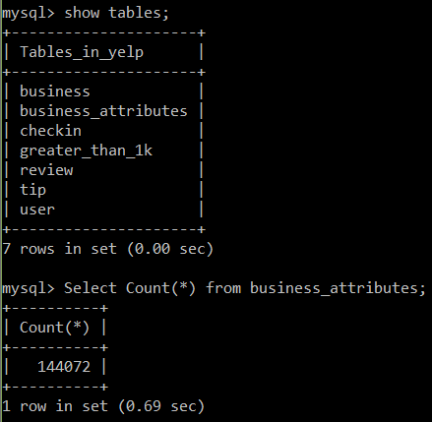

The following is a screenshot showing 10 of the rows of business_attributes table (sorryI can’t make the image larger an still fit correctly on the page).

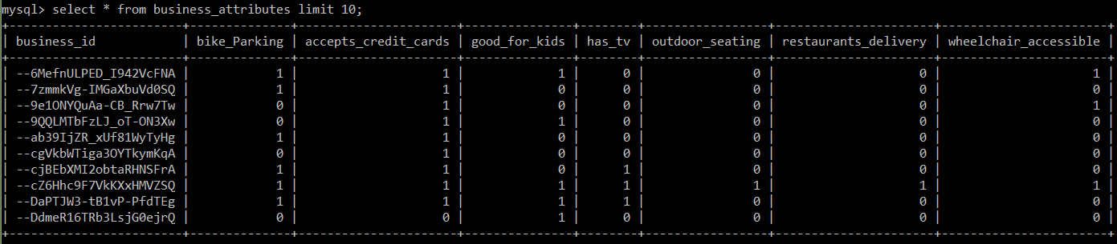

To test the effect of vertical partitioning of the business table I ran one Join query that used the table that was created from the partitioned data (attributes data of business tables) and ran one query that used just the full business table. The query finds the number of businesses that have greater than 300 reviews and have a **BikeParking** attribute that is true. As you can see from the screen shot, the query that did not use the partitioned data took twice as long! This shows how valuable vertical partitioning can be.

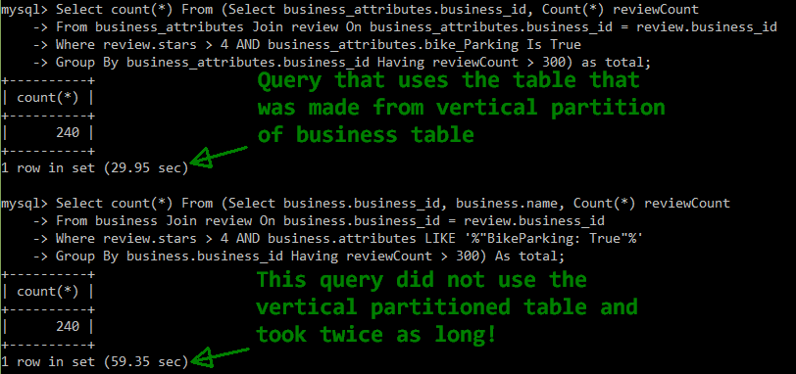

Similar performance gains can be obtained by using a horizontal partition as well. I could select all the businesses that have greater than 5 stars and put them into a separate table. Then queries that used this data would run much faster. I suspect the temporal gains would be similar to that of using vertical partitioning. Adding an index will also help speed up search queries. Initially, I did not give the review table an index to facilitate importing the data quickly – the less constraints imposed the quicker the data loading. I altered the review table by making the review_id an index.

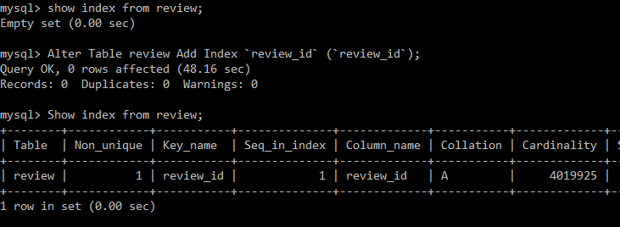

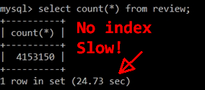

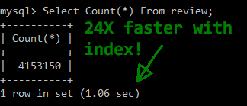As the screenshots to the left show, adding an index can greatly improve select queries! This concludes the MySQL section. Next, I explore a completely different way to store and access data; a way that is a better fit for big data.

# Hadoop Map Reduce

A Hadoop system is very different than a MySQL system. For one, there is no strict schema imposed on the data. The data in a Hadoop system are just text files that reside in the Hadoop Distributed File System, HDFS. In a Hadoop system, your data is divided into block size chucks. Queries are answered by running functions on the data in parallel. Hadoop Map Reduce is a programming model designed for big data batch processing. To use Map Reduce, you must decompose your problem into two tasks - a map task and a reduce task. Each task should take in as input a key and a value pair and return a key and a value pair. After you have decided on how you are going to decompose your problem, you need to write it as code – you write a map function and a reduce function. The map function will be run on each node where the data is, then the output of all the map jobs will be grouped and sorted automatically by Hadoop. Next, the reducer function is applied to the data and the output of the reducer will be hold the query results. It helps to be familiar with functional programming when thinking about writing map and reduce functions. A Map Reduce job can be used as a way to transform data, preparing it for the next stage of the big data lambda architecture.

## Setup

To answer queries using Hadoop Map Reduce, I installed the HortonWorks big data platform which includes a Hadoop system. HortonWorks requires a virtual machine manager for it to run in, so the first step was to install Virtual Box. I visited the Virtual Box website and downloaded an installer for my machine. The installer had no problems installing Virtual Box on my machine. After I installed it, it was necessary for me to go into the BIOS settings of my machine and enable virtualization. Without this Virtual Box will not run. Then I visited hortonworks.com and downloaded the version of HortonWorks for VirtualBox. After installation, you simply start the Virtual Box virtual machine monitor and select to run Horton Works.

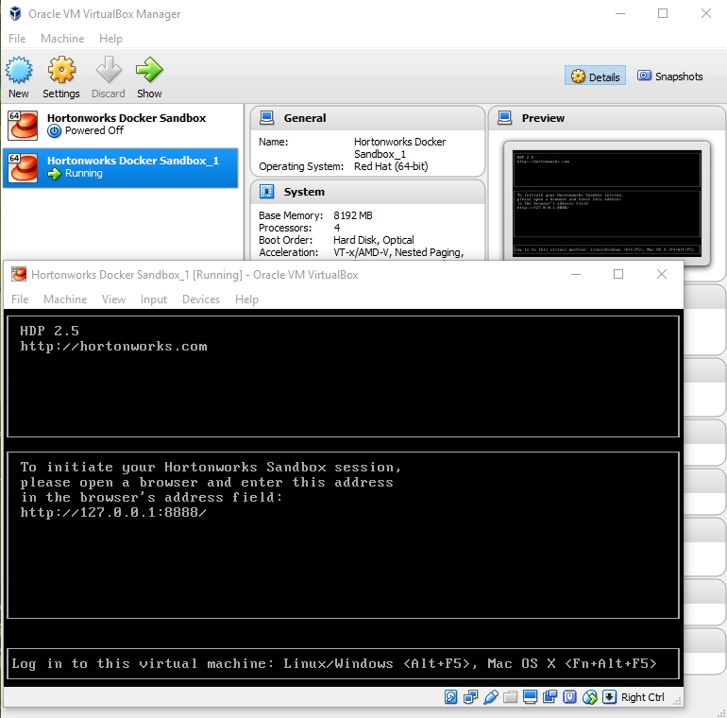

It takes a minute to startup so you must be patient. After startup, open a web browser and go to http://127.0.0.1:8888/ to log in. Be sure to disable pop up blocking on your web browser. You will be prompted to log in. I used the default credentials to log in to the HortonWorks system. The user name and password is maria_dev. After logging in you are brought to the HortonWorks dashboard. From here, you can make many choices. To see the files you have in the Hadoop system, you navigate the **Files View**. On the next page, select **user,** and then you are brought to the place where your files will be displayed. An image of this place can be seen in the ETL section below.

## Database / Schema

As mentioned in the beginning of the Hadoop section, a Hadoop database is just a collection of text files. These files are divided into block-size chunks to facilitate running map functions over the data in parallel. The block-size of a Hadoop system is 128 MB, which is much larger than the block size of normal computers. The text files can be in any form you want, but they should have some sort of structure to them so that processing them with code can be achieved relatively pain free. I chose to use the CSV file format for my data.

## ETL

For this assignment, I decided to export the Yelp data from MySQL since it was relatively clean data. I used the ‘INTO OUTFILE’ command. For example:

**(SELECT 'review_id', 'user_id', 'business_id', 'stars', 'date', 'text', 'useful', 'funny', 'cool', 'type')**

**UNION**

**(SELECT review_id, user_id, business_id, stars, date, text, useful, funny, cool, type**

**FROM review**

**LIMIT 3000000**

**Into Outfile 'C:/ProgramData/MySQL/MySQL Server 5.6/Uploads/review3.txt'**

**Fields Enclosed By '"' Terminated By '|||' Escaped by '"'**

**Lines Terminated By '\r\n');**

The previous SQL command extracts data from the review table and places it in a text file. The values in the text file are separated by three pipe symbols. I did not use three pipes as a separator for every tables data. For the business table I used a comma as a separator. Some of the values in the review table contained many commas so it made sense to use a separator other than a comma to keep the values separate. I choose to extract a relatively small volume of data – 100,000 records from each table. However, for the review data, I also extracted a much larger chunk of data, 2.1 GB file, so I could run a MapReduce job on data that is larger than the HDFS block size.

After I extracted all the data I needed to setup the Big Data platform, HortonWorks Sandbox. I downloaded a virtual machine monitor called Virtual Box and installed it. Then I downloaded the Sandbox version from the HortonWorks website for Virtual Box. It was a simple matter to setup. I followed the instructions provided by HortonWorks to setup the Sandbox using Virtual Box. The instructions can be found here: <https://hortonworks.com/wp-content/uploads/unversioned/pdfs/InstallingHortonworksSandbox2onWindowsusingVB.pdf>

You must ensure the computer you are planning to use with the Sandbox has Virtualization enabled in the BIOS. I initially did not have it enabled and received an error when starting up HortonWorks. When you start up the Sandbox the virtual machine is a little slow, but be patient. Then you will be prompted to open a web browser and login.

These are the steps to get into the HortonWorks Sandbox once the virtual machine monitor loads the Sandbox virtual machine.

* Enter <http://127.0.0.1:8888> in a web browser.
* In the login screen the presents itself enter **maria_dev** as the username and password
* You will be presented with the Ambari GUI environment. The first page is called the dashboard.
* To see the files for the user you are logged in under, maria_dev, you must select the file view, as shown in the image below.

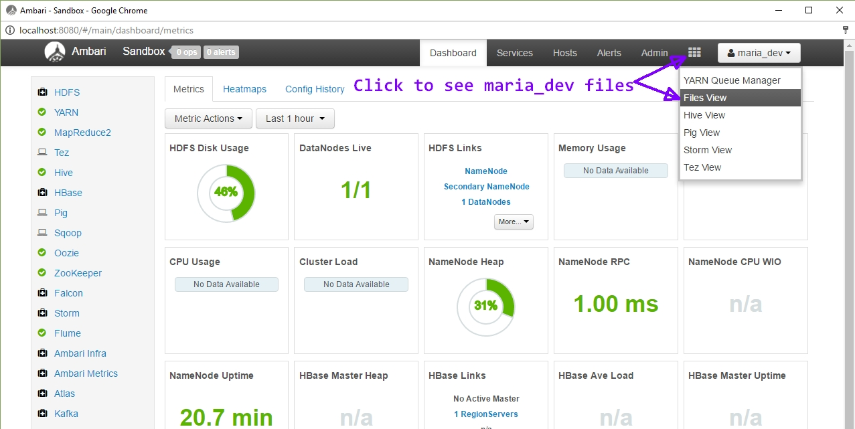

**Loading the Data**

It is possible to use the Ambari GUI to transfer the Yelp data files into the HortonWorks Sandbox, but I choose to use the command line. I decided to do this to avoid any timeout errors and it is typically faster to transfer files without a GUI. Unfortunately, I discovered that it is a three-step process to transfer files using the command line.

**Three steps to transfer files into HortonWorks using a command line:**

1. **scp -P 2222 <local path of file> < user: path on remote HDFS>**
2. **ssh maria_dev@127.0.0.1 -p 2222     🡨** to login to Hadoop HDFS
3. **hdsf dfs -put <file_name> <dest. path in SandBox>**

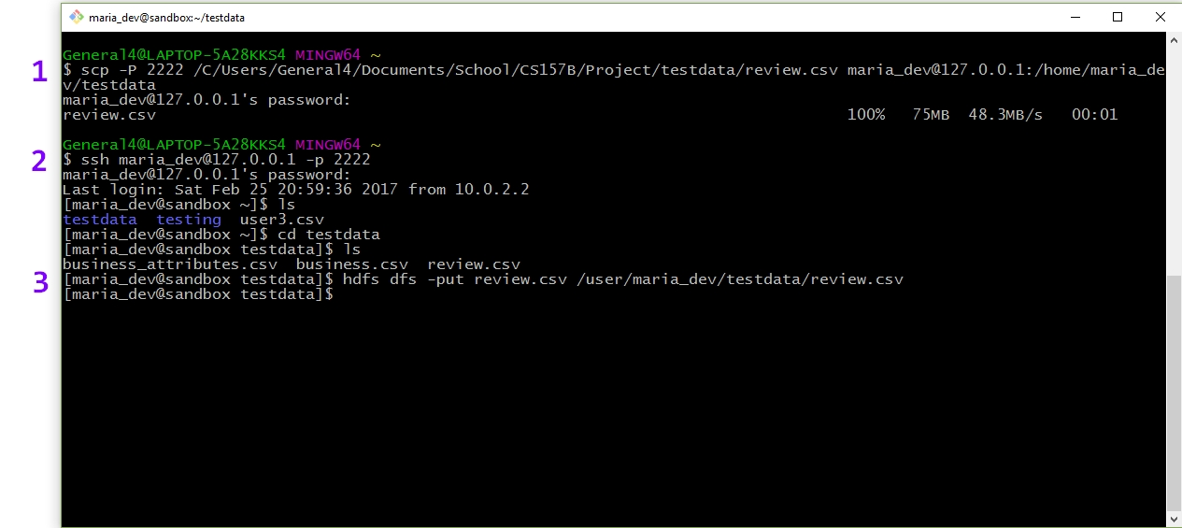

The image above shows the three-step file transfer process

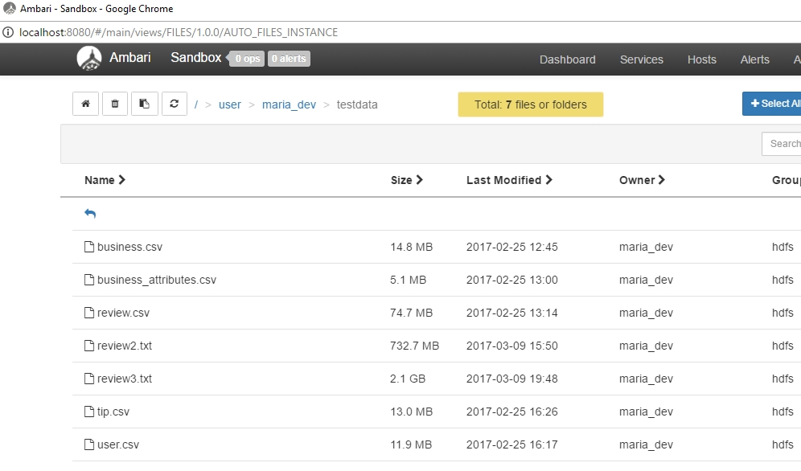

The image above shows my data files in the Sandbox. Notice that there are three review files of varying sizes. I was experimenting running MapReduce jobs with different sizes of input data.

## Queries

**Query #1:** Find average review rating for all businesses in a specific zip code

To solve this using MySQL I would write a query like the following:

**SELECT postal_code, AVG(stars), count(*) AS business_count**

**FROM business**

**GROUP BY postal_code**

**ORDER BY business_count DESC;**

+-------------+--------------------+----------------+

| postal_code | AVG(stars) | business_count |

+-------------+--------------------+----------------+

| 89109 | 3.5757068452380953 | 2688 |

| 85251 | 3.9410935738444195 | 1774 |

| 85281 | 3.67276814386641 | 1557 |

| 89119 | 3.489802855200544 | 1471 |

...

| 85253 | 3.9275568181818183 | 352 |

| 85248 | 3.690201729106628 | 347 |

| 85051 | 3.3771676300578033 | 346 |

| 89183 | 3.6246376811594203 | 345 |

+-------------+--------------------+----------------+

Solving the query using the Hadoop MapReduce API is much different. You must decompose the problem into a map task and a reduce task and then write functions for each of these. The map and reduce functions take key and value as inputs and outputs. The input data is divided into 128 MB chunks, which is the default HDFS block size and each map function works on a node where the data lives. This is called data locality optimization. This allows each map function to run in parallel. For my problem query, the map function needs to capture the postal code and star rating from each business and output a postal code key and star value for each distinct business. The output of the mapper stage is grouped and sorted automatically by Hadoop. This data is partitioned depending on the number of reducers. The default is one reducer task. If the output of the map stage will result in data that is greater than the HDFS block size, Hadoop will create more partitions and hence, more reducers to work on the data. The reduce task will iterate over the star values and compute a sum and then an average. A postal code and the average rating for all the businesses in that postal code will be the output of the reducer function.

The MapReduce job is written in Java using the MapReduce API. You must add many Hadoop JAR files to the project build path to compile the code. The JAR files can be obtained here: http://mvnrepository.com/artifact/org.apache.hadoop

Before trying to write map and reduce functions, I chose to write a regular Java program to zero in on the target data. The picture below shows this.

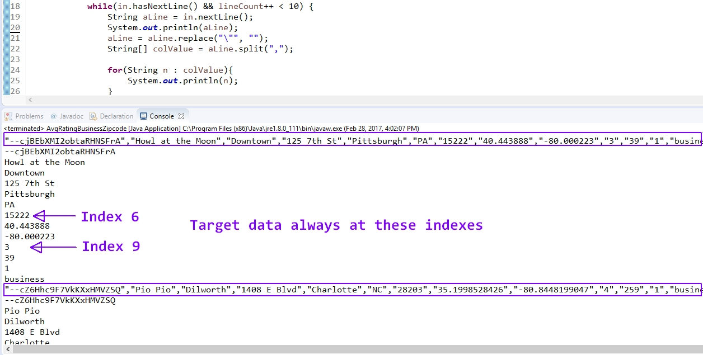

Once I had a better understanding of how to capture the target data, I proceeded to write a MapReduce job using the MapReduce API. To become better familiar with the API, I briefly reviewed the Hadoop MapReduce API documentation. It can be found here: [www.hadoop.apache.org](http://www.hadoop.apache.org) The following image is my map function.

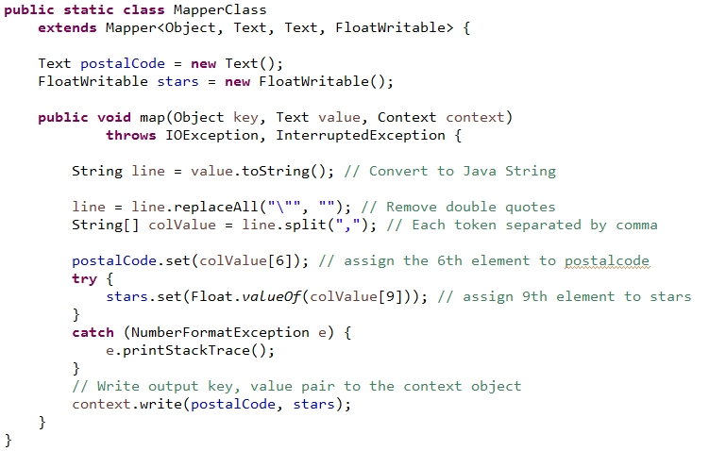

Notice that the key is not even used for the map function. The key, by default, is just the line offset in bytes from the beginning of the file. The map function removes double quotes from the text and tokenizes the line and places it in an array. Then, the values in the 6th and 9th index positions are captured and outputted as key and value.

The following is the reduce function.

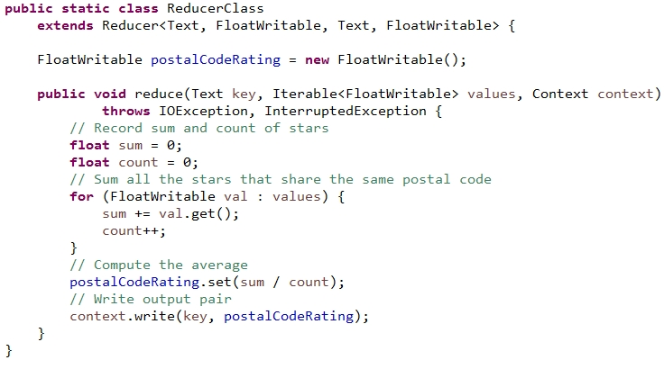

As mentioned above, the reduce function iterates over the array of values and computes and average. It then outputs the postal code and average star rating for all the businesses in that postal code.

Next, you must write a function that tells Hadoop all about your MapReduce job. This function is called the job runner. You must create an instance of a Job object and use this to configure the MapReduce job.

**Job job = Job.getInstance(conf, “PostalCodeRating”)** This line of code tells Hadoop that the class that contains the map and reduce functions is called PostalCodeRating. Additionally, you tell Hadoop what the input and output types for the map function is using the **setMapOutputKeyClass, setMapOutputValue** There are similar functions for the reducer function. The following is an image that show the job runner function for my MapReduce job.

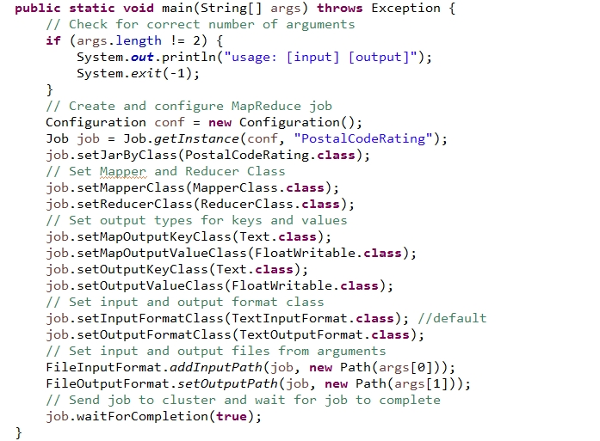

After the code is written, it must be compiled into class files. Next, these class files need to be packaged up and placed into a JAR file. Transfer this JAR file to Hadoop, because it is used to run the MapReduce job.

**The Command to Run a MapReduce Job**

**hadoop jar <jar_file_name> [mainClass] <datafile> <path to output directoy>**

**Forexample:**

**hadoop jar MapReduceTest.jar WordCount2 shakespeare.txt /user/maria_dev/test**

It’s important to note that the output directory, named test in the example above, needs to be unique because Hadoop will abort the MapReduce job if it is not. This is to prevent loss of any previous data analysis.

Depending on the size of the results of the MapReduce job, there will be one or more *part* files created. If the output size is more than the HDFS block size, the results will be in multiple files. For my job only a single output file was created, as seen in the following image.

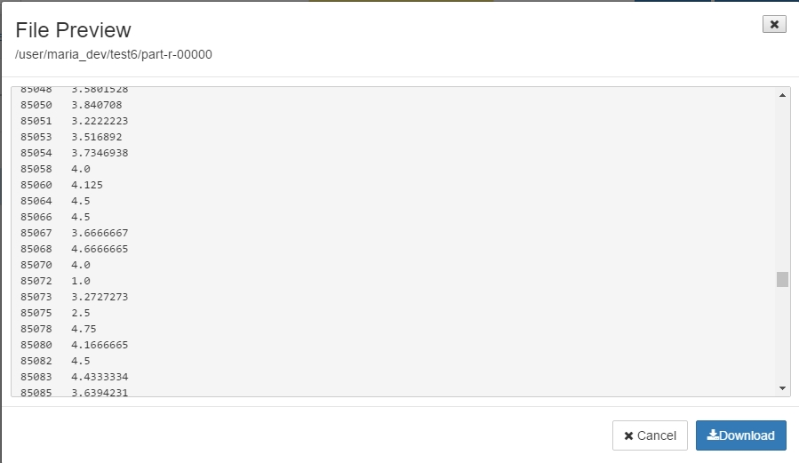

As you can see, the resulting output data is just like that of the MySQL output data.

**Scaling Out – Working on larger input data**

**Query #2:**

**Find all businesses that have over 1000 reviews and have a star rating greater than 4**

SELECT business_id, AVG(stars) AS starAVG, COUNT(*) AS reviewCount

FROM review

GROUP BY business_id

HAVING reviewCount > 1000 AND starAVG > 4;

I chose to write a similar query as the first to solidify my understanding of how to write a straight-forward MapReduce job.

For this query I will use a file named review3.txt which is 2.1 GB is size. By running a MapReduce job on a larger data size, there will be more map tasks created. Each map task will run in parallel on the node where the data lives. It’s important to note that just because the data input size has increased, it does not necessarily mean that more reducer tasks will also be created. The number of reducers is not based on the input data size. It’s more closely related to the map output data size.

Just as before I wrote a java program to zero in on the target data before trying to write a map and reduce function using the API. The contents of review3.txt had a lot of data the was not well formed. Some data spilled onto multiple lines. Since it was not the case that each line of data was a different record, my map function would have to do extra work to ensure quality data is outputted to the reducer. I needed to make a command decision on how I would ensure only good data left the map function. What I decided to do was throw away all malformed data. How did I do this? The values were separated by three pipe symbols so I used this to tokenize each line and place it in an array. Since, the review data contained 10 columns, only those lines that contained exactly 10 elements (values) where considered.

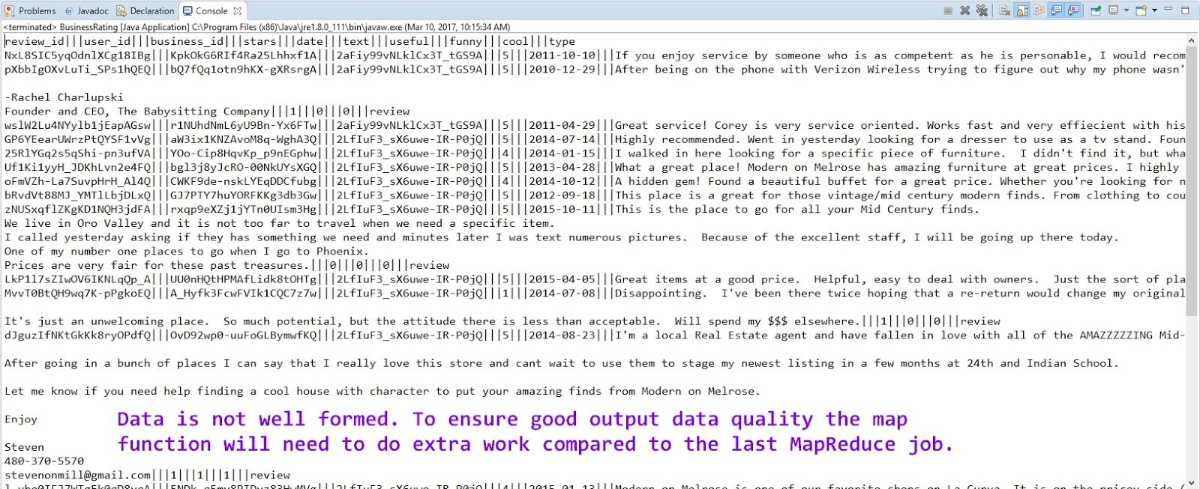

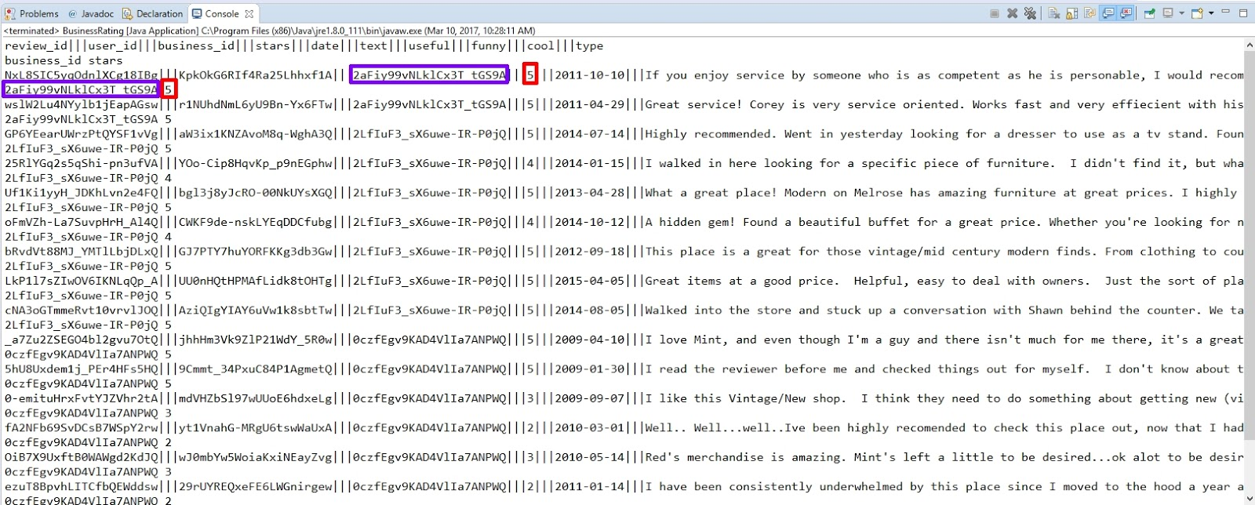

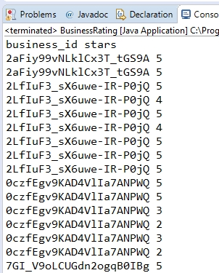

Next, I wrote code using the Hadoop MapReduce API

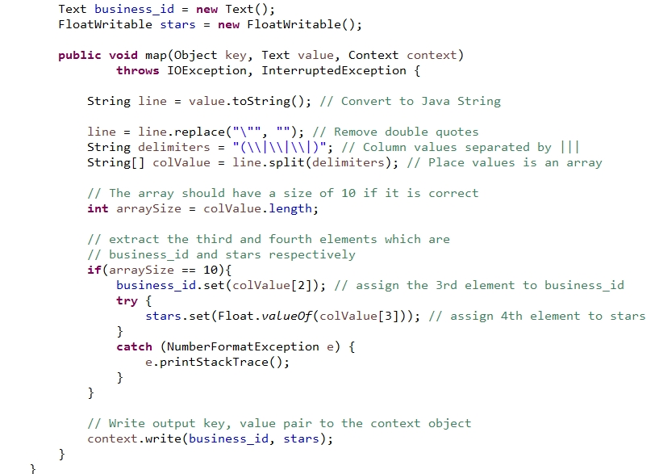

Like the previous map function, each line of text is turned into a Java string and quotes are removed. The string is tokenized using three pipe symbols as a delimiter and placed into an array. If the data is well formed, there would be ten items in the array. The function only considers arrays that have 10 elements. The values at index 2 and 3 are captured. These values correspond to the business_id and stars. In a real-world program I might also want to check the two extracted elements. For instance the business_id needs to be 10 characters and the stars should be a numeric and be in the range of 1 to 5. These are checks to ensure data quality.

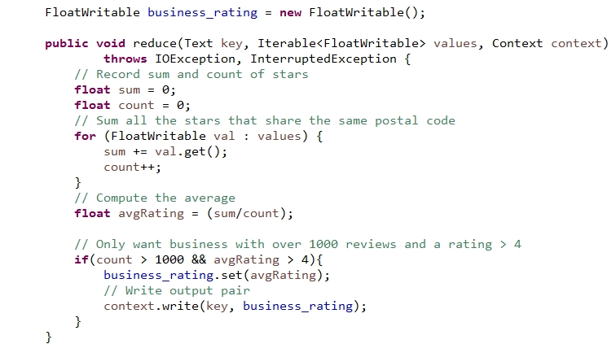

The reducer function does similar work as before, but this time only writes to the context object if the business has greater than 1000 reviews and a star rating above 4. This shows that each time a reducer works on a key, value pair, it does not necessarily have to output a key, value pair. The Job function was very similar to the last, so I will not show it here. Here is the output from running this job. Notice is has 18 map tasks.

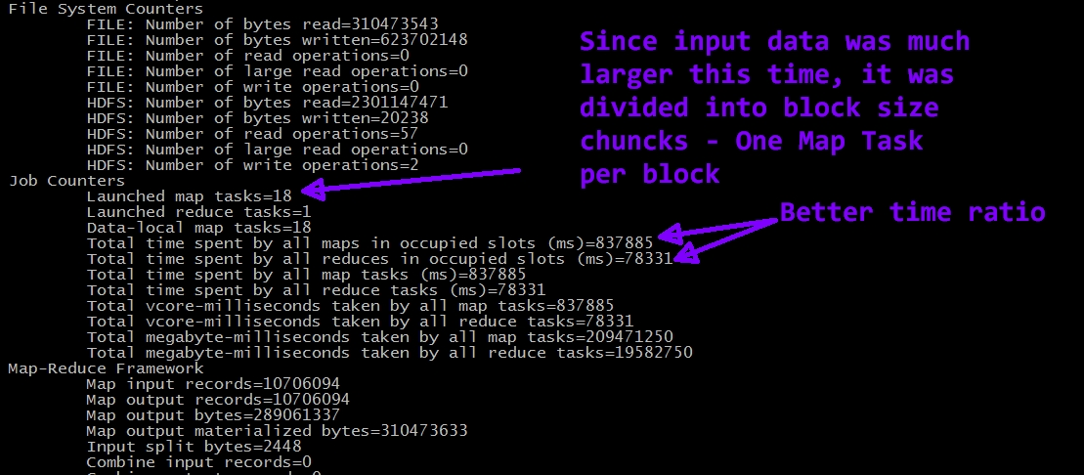

There are 18 map tasks this time since the input data was much larger. The data was divided into HDFS block size chunks. So this time there were 18 map tasks running in parallel. There still is only one reducer because the mapper output only required 1 reducer since the mapper output was relatively small. One part file was produced which was 19.8 KB.

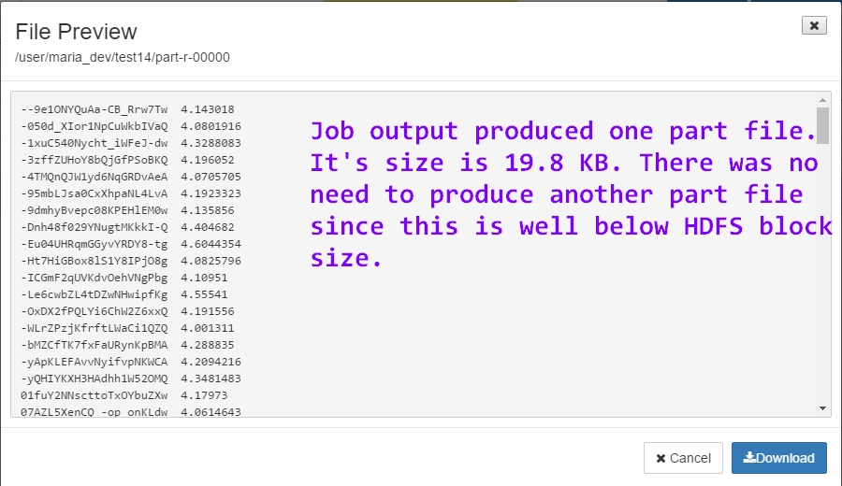

## Updates

Data in a HDFS is typically written once and read many times. When using Hadoop Map Reduce to query data, you are reading in all the data of a text file. Your functions do not operate on just a subset of a text file; the entire text file is processed during a MapReduce job. This is very different with MySQL where you can update a row or multiple rows. If you must update the data using Map Reduce, then your map and reduce functions that will transform the data somehow, will work on the entire data file and write the updated data to the HDFS as a different file. Using Hive to update data, may be a better choice. Hive is a higher-level abstraction over a Hadoop system. It has update support built-in. I did not perform any kind of update on the Yelp data using Hadoop Map Reduce.

## Data Quality / Consistency

My MapReduce job worked on clean, historical data. Because of this I had to do very little maintenance work in the mapper function to ensure it worked on the proper type of data. If this job was to be run frequently on newly acquired data, the mapper would have to parse the data and ensure that the values were of the correct type and in the correct form. The use of regular expressions would be required. With a MapReduce job, you cannot set tuple or attribute based checks on new data. The same is true if the data files are updated in the HDFS file system. Since there is no schema imposed on the data or constraint checks, you must program type checking and validation into your mapper function. One strategy may be to preprocess the data before letting the map function work on it. You could write a server-side script that works on newly acquired data, cleaning and filtering it.

**Data Integrity Checks**

One way to ensure data integrity is to verify that the data has not changed since it was stored. For each file stored in the HDFS, you could store some metadata with it. Part of the metadata could be a checksum. Then, the first thing that should be done when running a MapReduce job is to verify the input data against the checksum. If it is not correct, stop the job and find out why.

As mentioned earlier, checking input data as it is ingested to the HDFS would be wise. One could write a script that processes all input data and writes it to the HDFS along with a corresponding checksum. Then when the mapper function works on the data it must do less work as long as the check sum is correct.

**Combiner Function Optimization**

For map jobs that produce a lot of data using another functions that does internal reduction would make the reducers have to work less and there would be less data transferred to the reducers in the first place. To minimize data transfer to the reducers, write a Combiner function that performs reduction on the mapper output. In the case of my first example, the list of star ratings could be very large if the number of businesses in the postal code was large. If a combiner function summed star ratings so the reducer only needed to compute an average, that would help performance. In the case of my job, not by much. But for big jobs, this would have a much better impact on performance.

Optimized reducer input < 94582, [ 345, 75 ] >

Sum of stars         number of businesses

## Performance Optimization

In query #2 I demonstrated that the volume of the input data has a direct relationship to the number of map tasks generated. This is because the input data is divided into block-size chunks so many map jobs can run in parallel. The number of reducer jobs does not depend on the size of the input data, but rather on the size of the output data from the map jobs. The time is takes the map jobs to run should be greater than the time it takes the reducers to run. If the map job time is greater than or equal to the reducer time, it is likely due to the volume of the input data not being very big. Hadoop is for big data, so using Hadoop as such is not taking full advantage of the system.

A good measure of performance is the CPU time spent on a job. On this last job, the CPU time spent was 213130 ms. I want to try and improve this be lowering this value. The HortonWorks Sandbox GUI has some features that allow you to try and improve the performance of your MapReduce jobs. To make any adjustments to the default settings, you must log in as an administrator. Then click on MapReduce2 in the left menu followed by config. After you make any adjustments, a message will be displayed telling you to restart the MapReduce service.

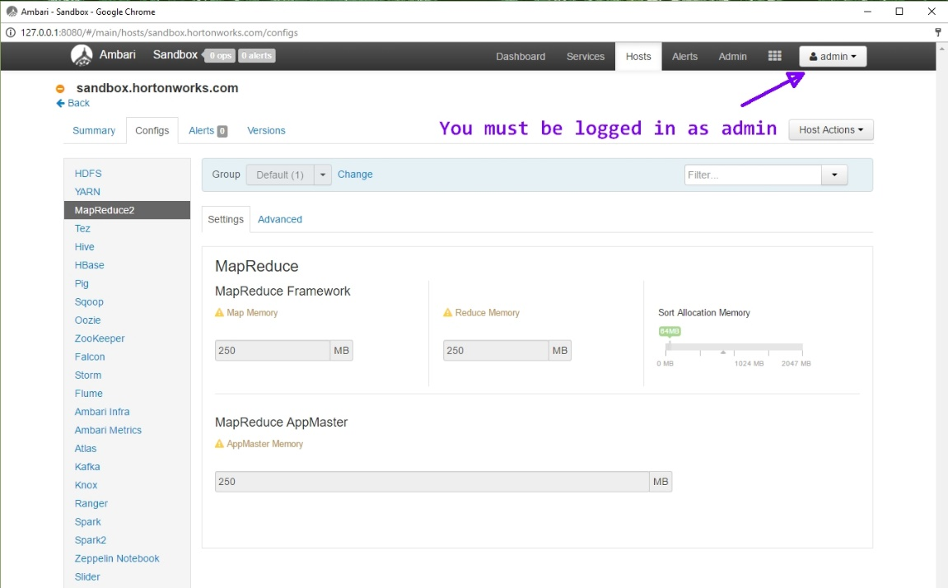

Notice that the virtual memory for a single map and reduce task is flagged in yellow because they are only set at 250 MB each.

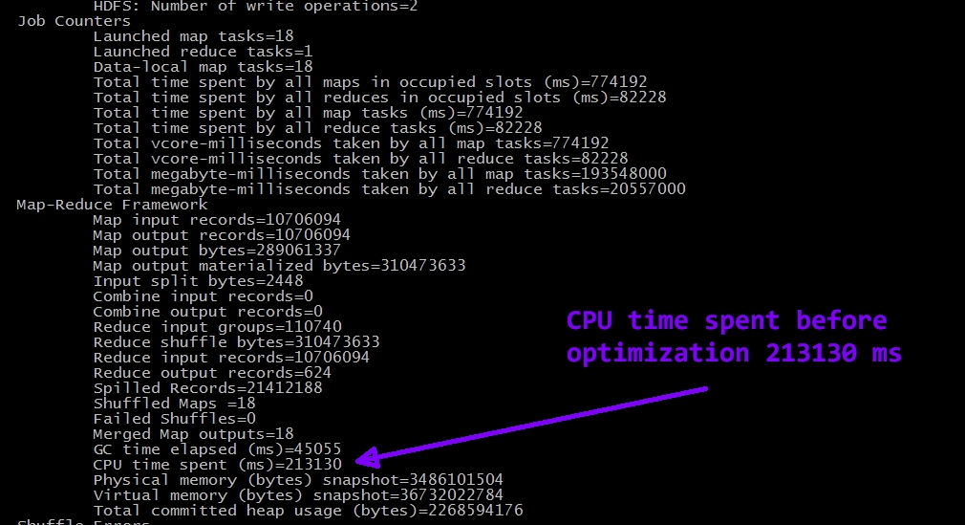

Take note of the CPU time spent before optimization in the above image.

Below is an image showing that I increased the virtual memory to .5 GB each. Now they are green because they are not below the recommended amount.

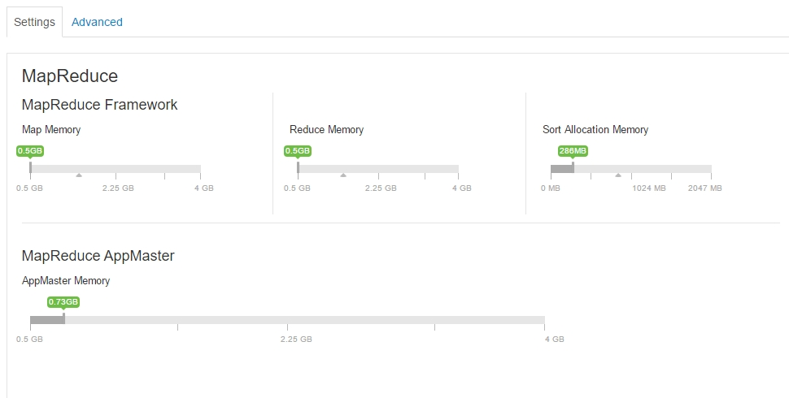

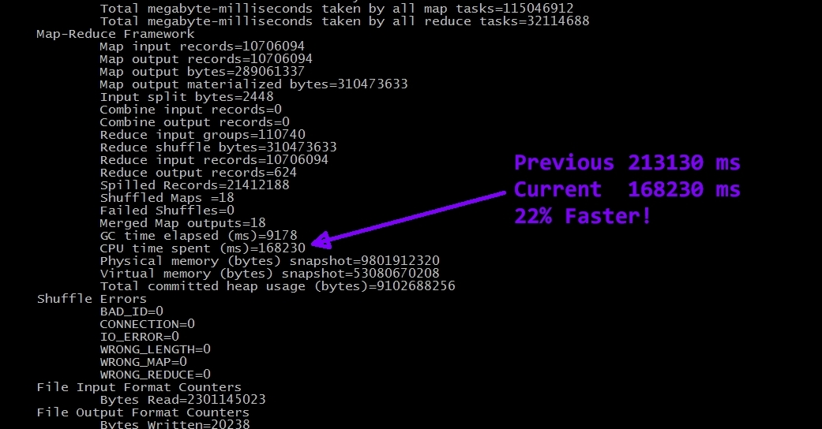

After running the job again, there was a 22% increase in CPU performance!

**Scaling up to boost CPU performance**

Now I am going to try and increase CPU performance by increasing the Virtual Cores. Select the Yarn menu on the left and then select config. Under CPU you can see that the minimum setting for virtual cores is set at 1. I will increase this to force Hadoop to use more than one VCore. Then I will run the job again.

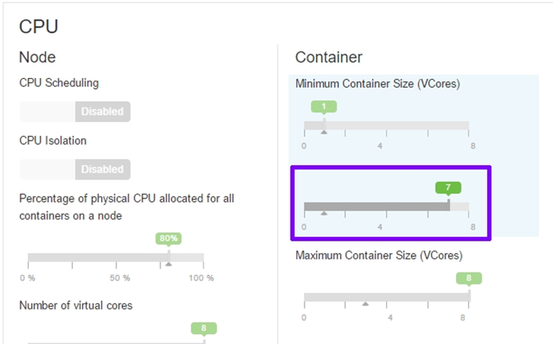

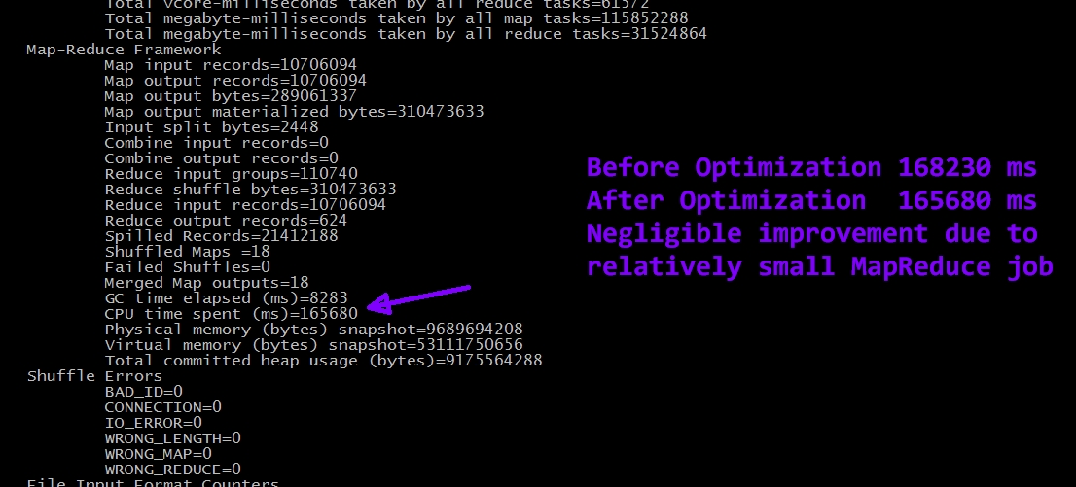

There was a slight improvement, but it is negligible. The MapReduce job that I am running probably isn’t large enough to benefit from using more than one VCore.

**Fine tuning a MapReduce job**

Hadoop works better with a small number of large files versus a large number of small files. If you have too many small files, each of which is smaller than the block size, then a lot of map tasks will be created unnecessarily. This causes a lot of overhead and can easily be avoided. When configuring the job don’t use the **FileInputFormat** when reading in the file. This format will cause splits to occur for each small file which cause many map task to be created. By specifying the **CombineFileInputForma**t small files will be combined and splits will be about the size of the HDFS block. This will cause less map tasks to be created, reducing overhead. Generally, the Map time should be greater than the reducer time. If it is not, then something is not sett up correctly. In my first example, I had a single map task that ran just slightly longer than the reducer. This is because the input file was small and so only a single map task needed to be created. In the second query, I used a much larger input file, so 18 map tasks where created and the ratio of map time to reducer time was improved.

# Spark

Spark is a multi-component, data processing platform. Some components of Spark are Spark Core, Spark SQL, and Spark Streaming. The Spark API supports programming languages such as Scala or Python. When working with Spark, you create resilient distributed datasets, or RDDs, that you use two types of operations on – transformations or actions. Transformations operate on each member of an RDD and return a new RDD. An action operates on each member of an RDD and returns a value. Spark is commonly used for extracting and transforming data. Spark can be used to batch process historical data or by using Spark Streaming, process real-time streaming data. In the examples that follow, I will use PySpark, which is the built-in Python API and command line tool. I will use Spark for batch processing and Streaming.

## Setup

I installed Spark in standalone mode. To do this, first I downloaded a pre-built Spark distribution from spark.apache.org/downloads.html. I downloaded the version with ‘hadoop’ appended to the file name, because I do not have Hadoop installed on my machine. I extracted the file and placed it C:\Spark. Even though Spark does not require you to have Hadoop installed, some components are dependent on the Hadoop common binaries. There is a program included with the Hadoop binaries called winutils.exe that you will need to use if you are going to setup Hive. Two other requirements are to have Java and Python installed, which I already did. For some reason, you must disable IPV6 for Java applications by running the following command as administrator from the Windows command prompt:

**setx /M _JAVA_OPTIONS “-Djava.net.preferIPV4Stack=true”.** You must set an environment variable to the Hadoop directory and the Spark bin directory if you want to use PySpark from any command window. After all this, you can test the Spark installation by typing pyspark in a Windows Command Prompt. The image below shows what should happen after entering the command.

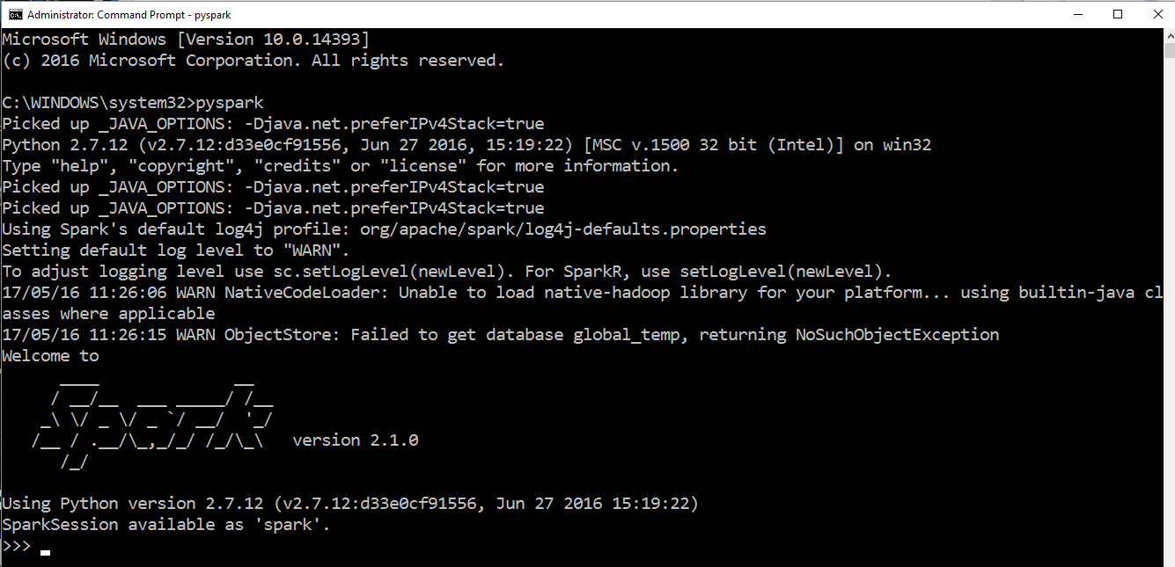

In addition to using a local Spark installation, I also created an account with Databricks and worked with Spark in the cloud. Databricks has an online interface that you can use to enter PySpark code and execute Spark jobs. In the ETL section I show you how I imported data into Databricks.

## Database / Schema

Similar to Hadoop, Spark operates on normal text files. Semi-structured file formats such as JSON is supported or even simpler formats like CSV. You can even use a text file that has no structure at all, but I don’t recommend this.

## ETL

**Extract Historical Data**

In addition of using the Yelp files from the previous assignment, Hadoop MapReduce, I chose to extract a subset of the Yelp data from MySQL that uses double quotes as a delimiter. I used the ‘INTO OUTFILE’ command and specified double quotes as a delimiter. Doing this allowed me to work with clean data. The code below shows a header being prepended to the data; my final solution used data files that did not include a header (I had to re-extract from MySQL).

(SELECT 'business_id', 'name', **…** 'stars', 'review_count', 'is_open', 'type')

Union

(SELECT business_id, name, **…** stars, review_count, is_open, type

FROM business

LIMIT 700000

Into Outfile 'C:/ProgramData/MySQL/MySQL Server 5.6/Uploads/business.txt'

Fields Enclosed By '"' Terminated By '||' Escaped By '"'

Lines Terminated By '\r\n');

I also extracted some of the Yelp data tables using the same command and specifying a comma as the delimiter. I did this because when I loaded the data into Databricks initially, I thought that you needed to create tables from the files and Databricks required a single character as a delimiter. Later, I learned that creating tables from the uploaded files was only necessary if you’re working with SparkSQL; since I did not work using SparkSQL, these tables were never actually used.

**Load Data**

Initially, I up-loaded the comma separated files to Databricks . However, after learning that it was not necessary to create tables after importing files into Databricks, I imported the double-pipe delimited files I exported from MySQL. These files were saved with the .txt file suffix. Importing files into Databricks is easy. It is accomplished using a GUI interface. Also, the uploads were relatively fast. Since I also installed Spark on my laptop I placed the same set of files I used for Databricks in a directory named data under my Spark directory on my laptop. It's important to note that before I could upload any data It was necessary to create a Spark cluster and notebook. This was a simple matter of making selections and clicking buttons. It was very straight forward. The screen shot below shows the what the Databricks user interface looked like after uploading review.txt. Each time I uploaded a file, I copied the file path to a file for reference.

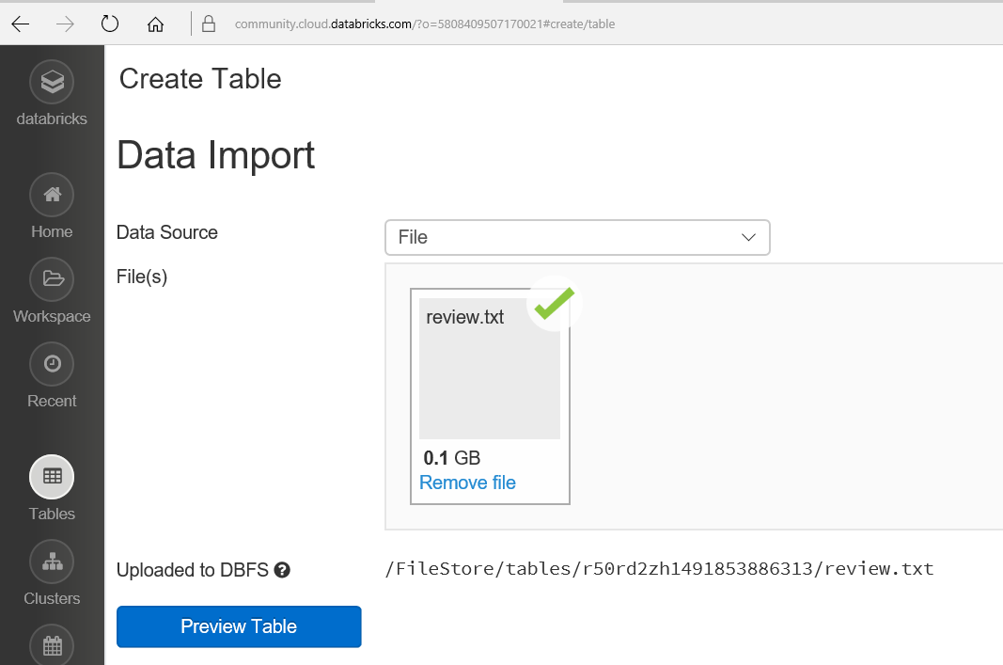

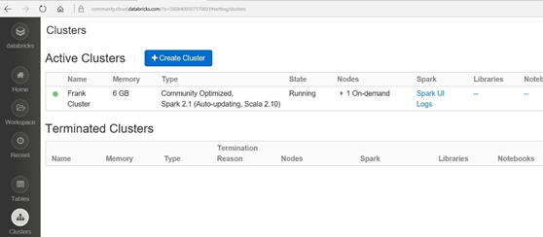

## Queries

Since I am familiar with Python, I decided to use PySpark to solve my query. To begin, I followed Databricks tutorials and ran some of the transformation and action commands in the Databricks notebook to get a feel for Spark. I became better acquainted with some of the functional programming by running many, many examples. There was lots of trial and error involved during this learning process. I worked in both Databricks and on my local Spark installation. I started this process over Spring Break, so luckily, I had extra time to dedicate to school work. Finally, I felt more confident and attempted (successfully) to write a pySpark program to answer the query I used in my Hadoop MapReduce project.

Problem: **Find average review rating for all businesses in a specific zip code**

Below is a screenshot of the program I wrote to solve this problem/query.

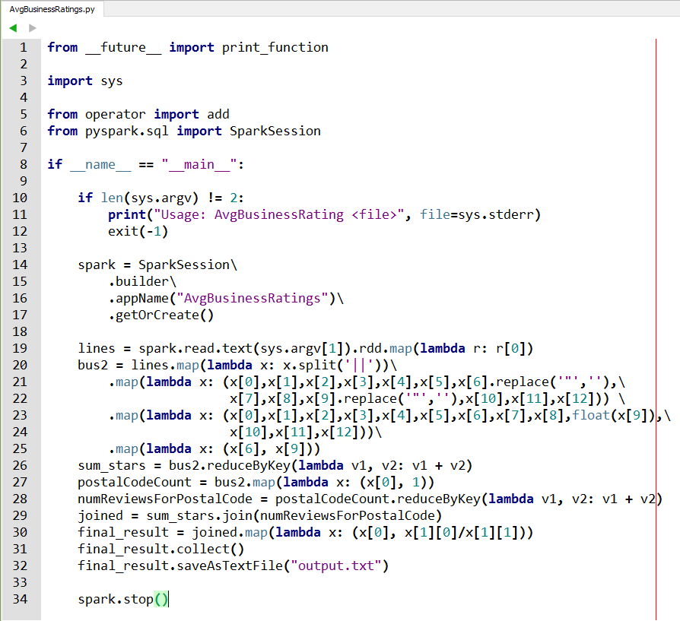

**Running the script on my local Spark installation –**

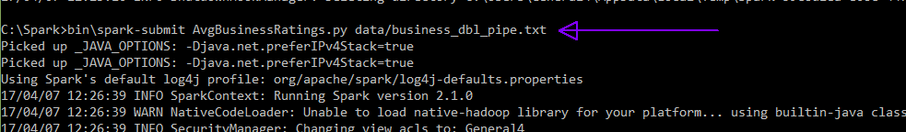

After running the command, Spark displays a lot of information in the command window. As you can see from the script, the final resulting RDD is saved in a directory named output.txt. The contents of this directory is shown below. The part files (part-00000 – part-00003) contain the output results.

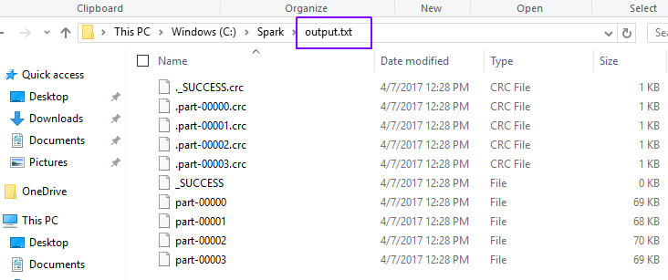

The image below shows a very small sample of the resulting output data.

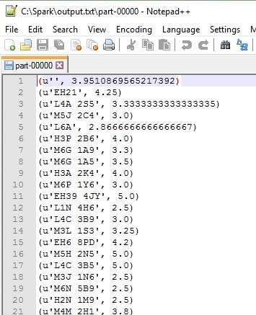

Now I will briefly explain the steps that I undertook to write the Python script shown above. Initially, I choose to work with a very small subset of the business table – only 10 records! When I successfully solved the problem, I would run it against a larger data file. I did this so I knew exactly what my data contained and could compare my expected results with the given results and know for sure whether there was a problem or not. I took baby steps and broke the larger problem into smaller problems.

1. For each postal code find the sum of the star ratings
2. For each postal code count the number of business reviews/ratings
3. Join the results from the previous two steps using postal code as a key
4. Compute the average for each zip code

Below are images that show the ‘baby steps’ I undertook. I used the pySpark terminal to run the commands.

Step 1.

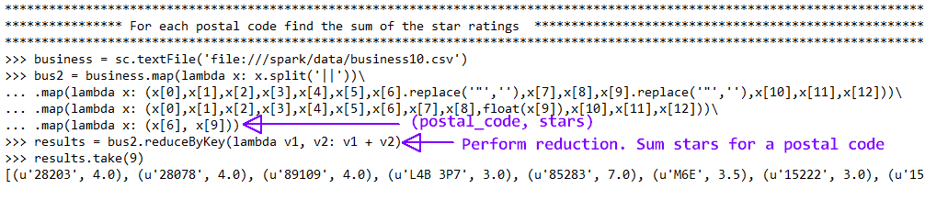

Step 2.

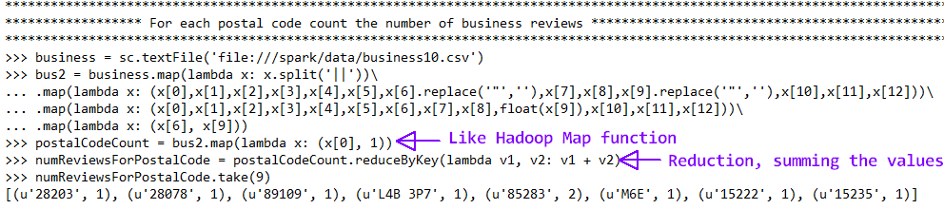

Step 3.



Step 4.

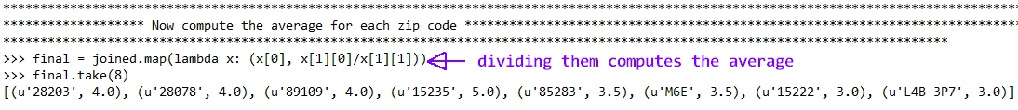

These steps combined are the main part of the python script I presented above. By looking at the output displayed in the terminal window, I determined the IP address of the Spark UI.

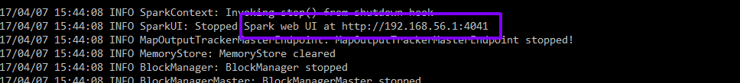

The Spark UI only stays up as long as the batch job is running, so it was necessary for me to refresh the page several times as the job ran to view different stages of the data. The screenshot below shows a job completed stage. Notice that the total time was 17 seconds and the total job duration took 11 seconds. I will talk more about this in the optimization section to come.

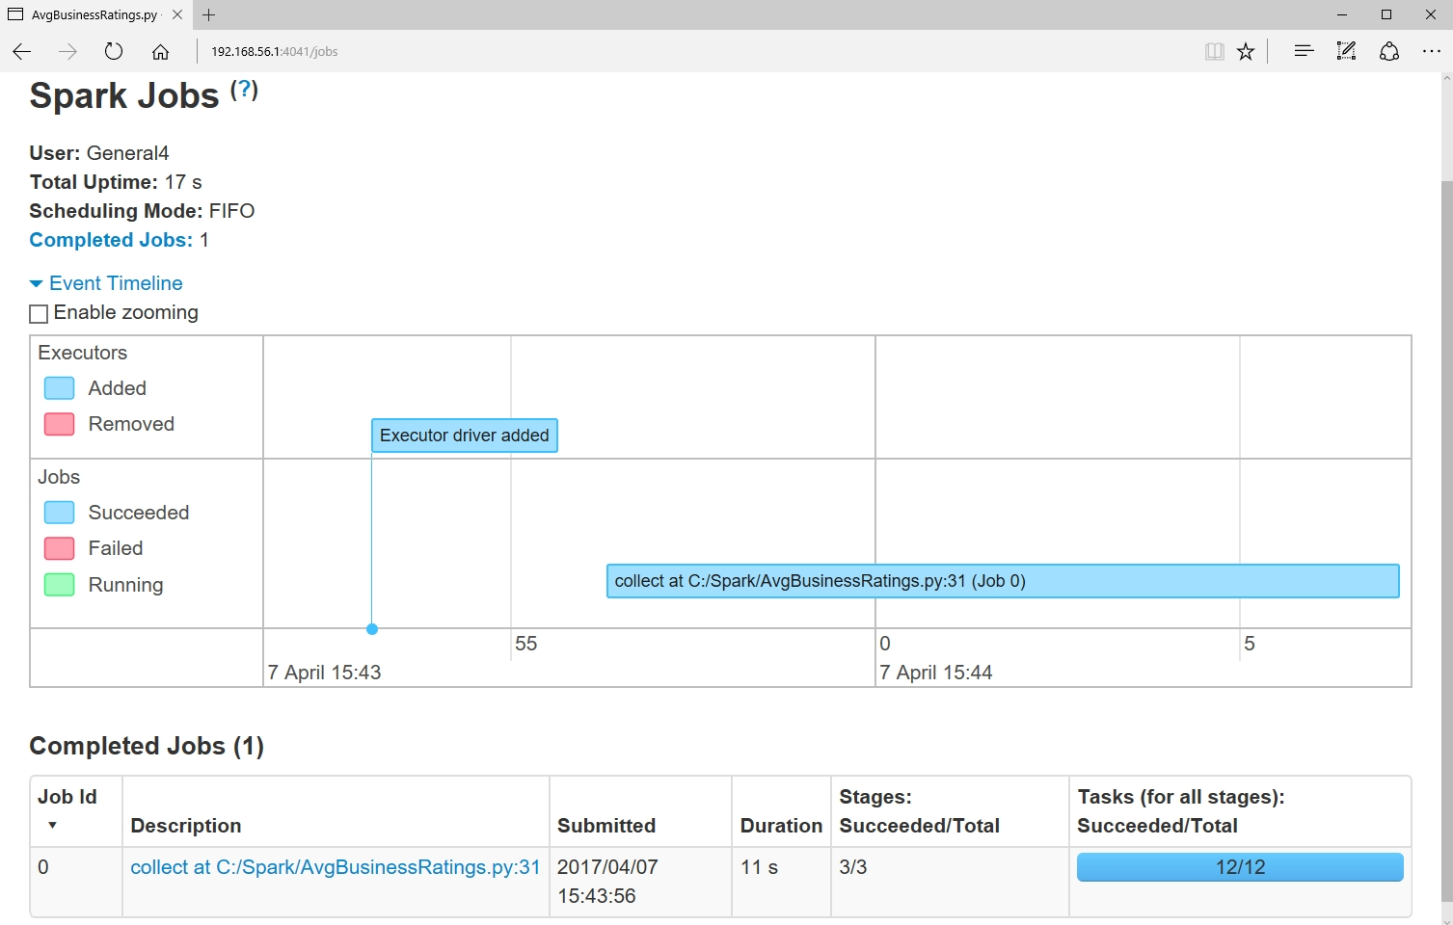

I also ran the script in my Databricks notebook. Just as on my local Spark instance, it was a success. The screenshot image below shows the code with some of the resulting output.

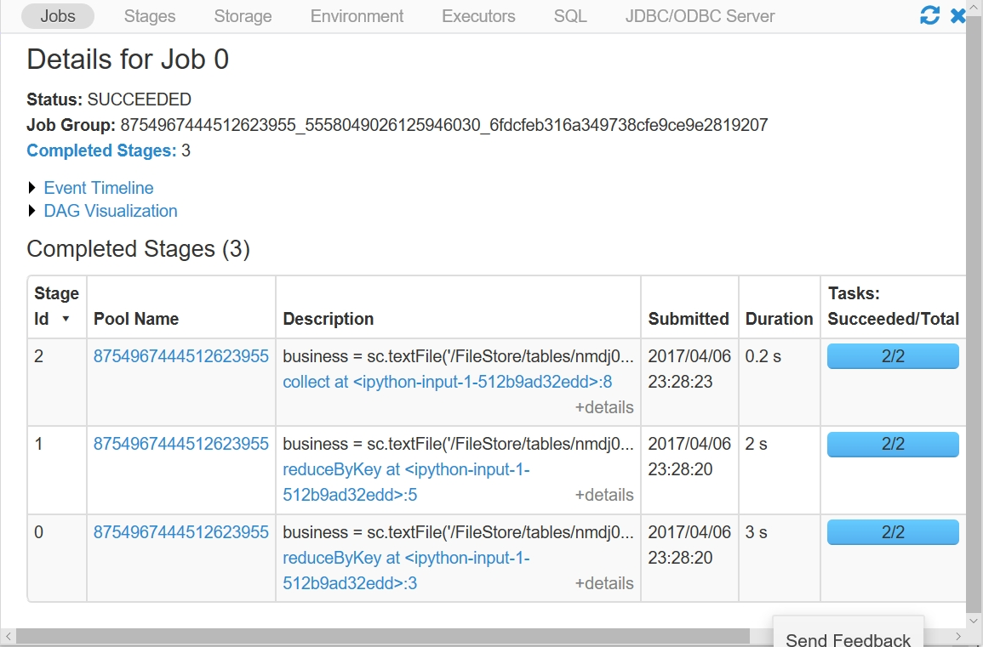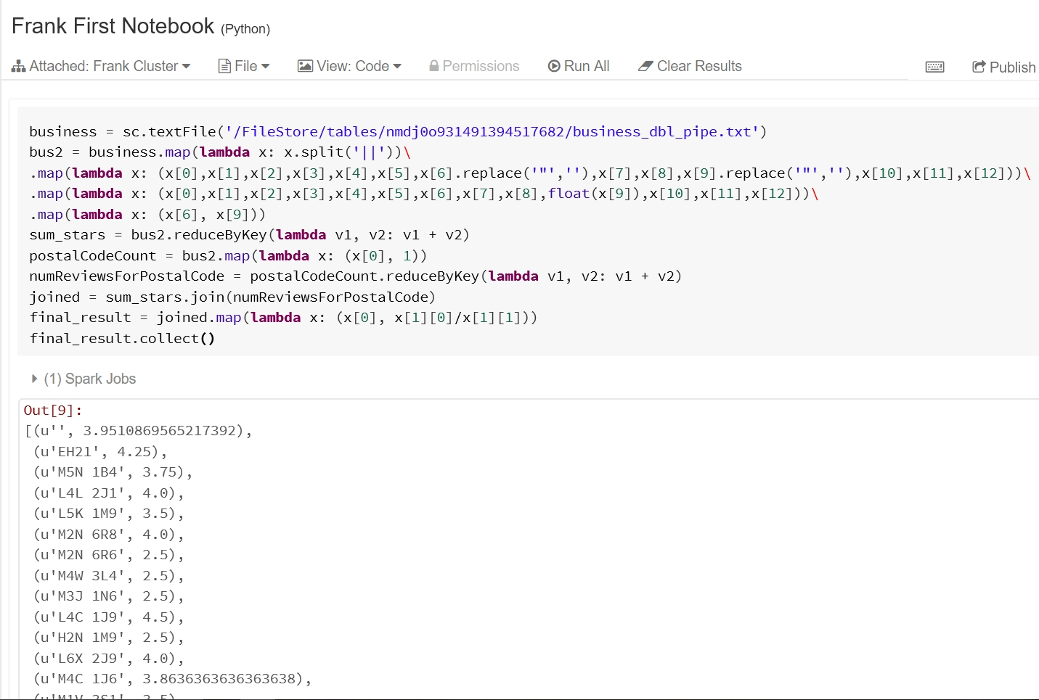

Notice that the total job duration was 5.2 seconds. This was about 50% faster than running it on my local machine. Another difference is the number of tasks. 12 tasks were run on my local Spark installation and only 2 tasks were run on Spark in Databricks.

## Update

Spark batch processing is not meant to perform updates to the data. Since it reads historical data, any new data would normally be captured by spark streaming. If one absolutely needs to update the historical data, they would need to manually change the text file and the batch job would need to be run again. If just appending to the end of a file, and you know the line number of the last line of text, you could run the batch job and just process the new lines and combine them with the previous results. This assumes that you persist or cache the previous results. Spark has many options for persisting RDDs. One option is to use caching which will save the resulting RDD in memory assuming there is enough memory. The batch job processing the new appended data can then be combined with the cached data. As long as the driver program is running, the persisted data remains intact. To combine previously computed RDD results that ran under a different driver with the results of the updated data, you must use Checkpointing. Checkpointing saves data to a file and is an expensive operation. I will not go into the details of checkpointing but instead focus on caching. Caching is simple, just use the cache method: **aRDD.cache()**

Caching is useful for performing optimization in Spark. I will explain why caching is necessary in the Performance Optimization section below.

In addition to the cache method, Spark offers the **persist** method which has more options called storage levels. Some storage levels include persisting to DISK_ONLY, MEMORY_AND_DISK, or MEMORY_ONLY. The last storage level mentioned is the same as caching the data. The following is an example using the persist method.

**aRDD.persist(storageLevel.MEMORY_AND_DISK_SER_2)**

## Data Quality / Consistency

Ensuring quality data can be accomplished by adding checks and filters in the code you write. For instance, after splitting a line of input using the split function, it would be a good idea to check that the length of the resulting list of objects the RDD contains, is the proper length before performing any work on it. Performing this check will filter out any bad lines of data and help to ensure more accurate data results. To accomplish this, the aptly named **filter** transformation function is used. Spark defines the filter function as such: ***filter(func)*** *- Return a new dataset formed by selecting those elements of the source on which func returns true.*

The following snippet of code is how I would use the filter function in my code to ensure quality data:

**...**

bus2 = business.filter(lambda x: len(x) > 0) \

.map(lambda x : x.split(‘||’)) \

.filter(lambda x: len(x) == 13) \

**...**

Since I know there are thirteen fields in the business data file I check that there are thirteen objects in a list after performing a split function. Performing type checking is another thing I could do to ensure data quality. Since I knew I was working with ‘clean’ data, I did not do any type checking before I casted the stars value to a float. However, in a real-world program I would want to do this. The following is an example of how I would do this in my program.

# The RDD is named bus2

**...**

**.**map**(lambda** x**:** **(**x**[**6**],** x**[**9**]))** **<--** second element must be a float

**try:**

afloat **=** float**(**bus2**[**1**]))**

**except** ValueError**:**

# Handle exception

**...**

If the second element of the RDD, bus2, fails the cast, I would not consider that data and move on to the next object list of the RDD. Ensuring that the input data is of the expected form and performing type checking will go a long way in ensuring that the data quality is optimized.

## Performance Optimization

In Databricks, there does not appear to be a way to tweak the settings to try and improve performace. This is because we are using a free, Community Edition of Databricks. My focus will be on improving performance of my local Spark installation. As mentioned briefly in the Update section above, caching is one way to perform performance optimization. Whenever an action function is called on an RDD, all previous transformations that were performed to create the RDD, must be performed again. To avoid this redundant work of re-computing an RDD for each action, Spark allows you to cache the RDD. As mentioned above, the Spark API provides the cache function to perform caching.

**aRDD.cache()**

At the very end of my program, I used the collect function which is an action. It returns a list that contains all the elements of an RDD to the driver program. Since my program did not use an action function until the very end, I did not cache any of the RDDs. However, to demonstrate when to use caching, I wrote a small program. I ran the program with and without caching and compared the results. To get a better idea of the power of caching, check out the snipet of code that follows. It caches the RDD so that after the first action function is called, additional action functions called on the RDD will not require the RDD to be re-computed. This will allow the data to be accessed faster.

#numbers is an RDD

...

numbers**.**cache**()** # cache the RDD

numbers**.**count**()** # triggers RDD computation

numbers**.**min**()** # No RDD re-computation required

numbers**.**max**()** # No RDD re-computation required

...

The following code captures the stars values and runs actions on them with and without caching. I compared the results on both my machine and Databricks, for each case the cached version performed better.

data **=** sc**.**textFile**(**'/FileStore/tables/nmdj0o931491394517682/business_dbl_pipe.txt'**)**

# Extract only the star values and turn into floats

stars **=** data**.**map**(lambda** x**:** x**.**split**(**'||'**))** \

**.**map**(lambda** x**:** **(**x**[**9**].**replace**(**'"'**,**''**)))** \

**.**map**(lambda** x**:** **(**float**(**x**[**0**])))**

#stars.cache()

stars**.**count**()** # Actions triggers RDD re-computation

stars**.**min**()**

stars**.**max**()**

stars**.**stats**()**

stars**.**collect**()**

spark**.**stop**()**

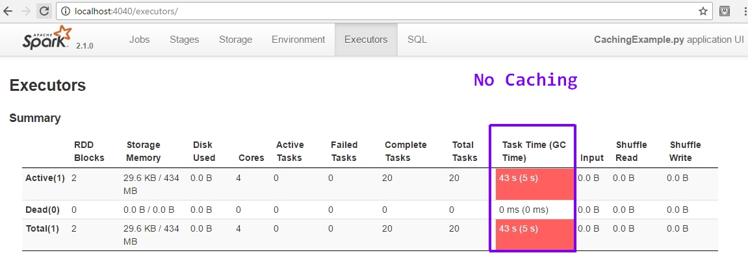

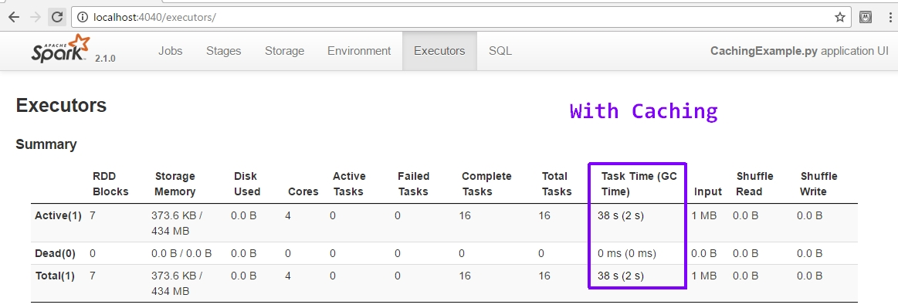

The code was much faster on Databricks, but I got the same results – caching was faster.

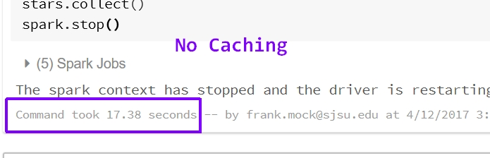

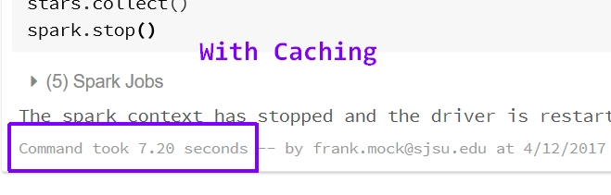

Another way to improve performance in Spark is to ensure you are using the correct reduction transformation function. When performing reduction for the purpose of aggregation operations, it’s better to use the **reduceByKey** or **foldByKey** functions versus the **groupByKey** function. This is because, groupByKey will cause more data to be transferred when the data is shuffled. In contrast, reduceByKey, combines the results of the aggregation operations before the shuffle which results in better performance. I changed my code to include a groupByKey function in place of one of the reduceByKey functions. I wanted to compare the execution time of each to see how much groupByKey would slow down the execution time.

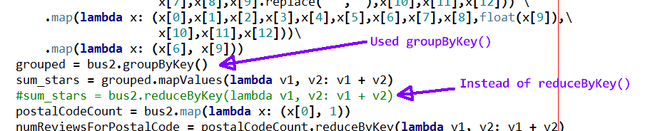

Unfortunately, I continually kept getting errors. The error messages did not directly reference my code as the source of the problem, so I was unsure what I was doing wrong.

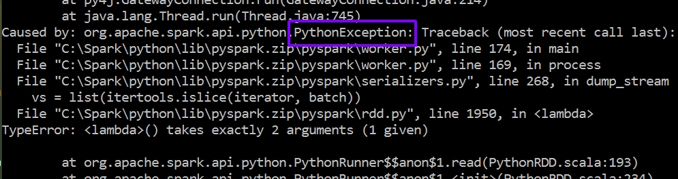

At least I learned from reading tutorials and Spark documentation that it is much better to use reduceByKey versus groupByKey to reduce the amount of data being transferred during shuffle operations. I wish I could have seen how using groupBykey would have affected by code, but due to the amount of time this Spark project is taking I had to move on to other school work.

One final thing I would like to mention with regards to performance optimization, is that I noticed when my scripts ran on Databricks they ran faster than on my local machine. They were working with the same data so I found this fact interesting. I tried to determine why they had different execution times, but could not determine why. I can only guess that Databricks is optimized in some way or has more dedicated memory. On my machine the number of tasks was double than that of Databricks. Perhaps this is a clue to why it was slower. Maybe, the increased number of tasks caused more shuffling which resulted in increased job time.

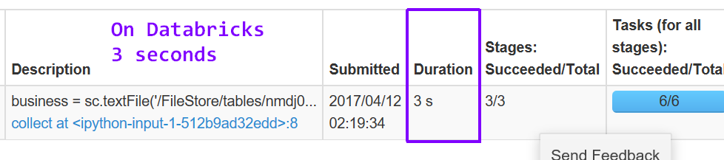

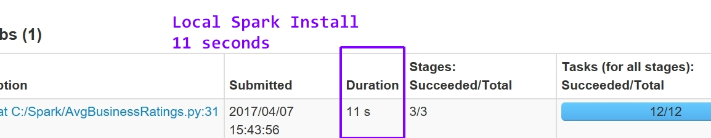

**Accumulator Example**

An accumulator is an updateable, shared variable that supports parallel processing. A broadcast variable is a read-only shared variable. Both accumulators and broadcast variables are made available to all worker nodes in a cluster. I wrote a very simple example program to demonstrate the use of an accumulator and a broadcast variable. To reduce the amount of filtering and data checking code (review data is dirty), I worked with a very small subset of cleaned review data. It finds the number of reviews that contain the words ‘good’ or ‘great’.

# Accumulator and Broadcast Variable Example

**from** __future__ **import** print_function

**import** sys

**from** operator **import** add

**from** pyspark**.**sql **import** SparkSession

**from** pyspark **import** SparkContext

sc **=** SparkContext**()**

**if** __name__ **==** "__main__"**:**

**if** len**(**sys**.**argv**)** **!=** 2**:**

**print(**"Usage: AccumulatorExample <file>"**,** file**=**sys**.**stderr**)**

exit**(-**1**)**

spark **=** SparkSession\

**.**builder\

**.**appName**(**"AccumulatorExample"**)**\

**.**getOrCreate**()**

# The words we are looking for

words **=** **[**"good"**,** "great"**]**

# Create a broadcast variable named target_words

target_words **=** sc**.**broadcast**(**words**)**

# Initialize accumulator

word_count **=** sc**.**accumulator**(**0**)**

review_data **=** spark**.**read**.**text**(**sys**.**argv**[**1**]).**rdd**.**map**(lambda** r**:** r**[**0**])**

review_words **=** review_data**.**map**(lambda** x**:** x**.**split**(**"||"**))** \

**.**map**(lambda** x**:** **(**x**[**5**].**replace**(**'"'**,**''**)))** \

**.**flatMap**(lambda** line**:** line**.**split**())** \

**.**map**(lambda** x**:** x**.**lower**())** \

**.**filter**(lambda** x**:** x **in** target_words**.**value**)**

# Define a function to increment accumulator

**def** inc_accumulator**(**word**,** word_count**):**

word_count **+=** 1

review_words**.**foreach**(lambda** x**:** inc_accumulator**(**x**,** word_count**))**

# Display results

**print(**"Total reviews with good or great is: " **+** str**(**word_count**.**value**))**

#review_words.collect()

#review_words.saveAsTextFile("review_words")

spark**.**stop**()**

I used spark-submit to run the script.



The results of the script

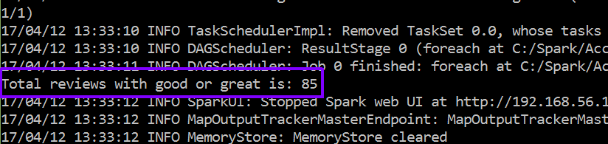

I know this result is correct because I also printed to file and the line count is 85 

**Spark Streaming**

**Extract Data**

I did not need to extract any additional data to work with Spark Streaming. My existing data was used as an input stream. How I accomplished this is explained in the next section.

**Load Data**

Spark Streaming requires a DStream Source that provides data that updates or continually changes., I chose to use the **socketTextStream** method from the Streaming API to create a DStream from an input TCP source. To provide a streaming input source, I used a simple shell script that reads the lines of a Yelp data file, business_dbl_pipe.txt, and every second sends a line to port 9999 of localhost on a NetCat server. The one second interval is the input data’s velocity. Port 9999 will provide input for my Spark Streaming script. This stream of data can be thought of as new user input data being captured from a website.

$ while read line; do echo -e "$line\n"; sleep 1; done \

> < business_dbl_pipe.txt | ncat -lk 9999

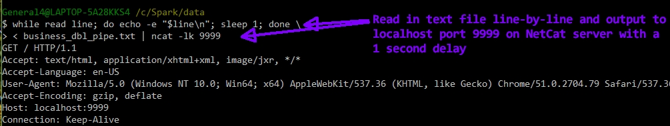

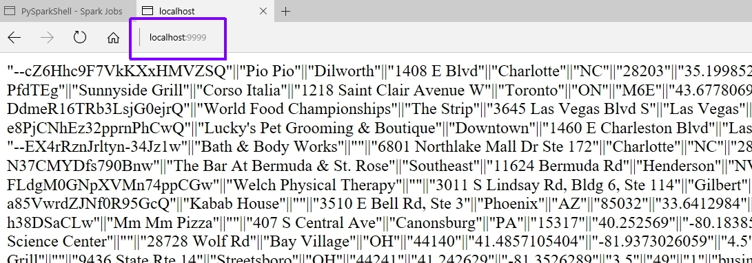

When doing batch processing with Spark, you do not need to instantiate a SparkContext since it is done automatically for you. This is not true with SparkStreaming; you must explicitly create a StreamingContext. The following lines of code show how my script instantiates a StreamingContext and creates a connection to the data stream. Notice that the StreamingContext constructor has a numeric batch duration argument, which is the number of seconds that streaming data will be split into batches.

**ssc = StreamingContext(sc, 10)** # Instantiate a StreamingContext – uses an existing SparkContex, sc

**lines = ssc.socketTextStream('localhost', 9999)** # Connect to the data stream

**Query**

For Spark Streaming, I used the same query as Spark Batch.

Problem: **Find average review rating for all businesses in a specific zip code**

**import** re

**from** pyspark**.**streaming **import** StreamingContext

ssc **=** StreamingContext**(**sc**,** 10**)**

lines **=** ssc**.**socketTextStream**(**'localhost'**,** 9999**)**

bus2 **=** lines**.**filter**(lambda** line**:** len**(**line**)** **>** 0**)** \

**.**map**(lambda** x**:** x**.**split**(**'||'**))** \

**.**map**(lambda** x**:** **(**x**[**0**],**x**[**1**],**x**[**2**],**x**[**3**],**x**[**4**],**x**[**5**],**x**[**6**].**replace**(**'"'**,**''**),**x**[**7**],**x**[**8**],** \

x**[**9**].**replace**(**'"'**,**''**),**x**[**10**],**x**[**11**],**x**[**12**]))** \

**.**map**(lambda** x**:** **(**x**[**0**],**x**[**1**],**x**[**2**],**x**[**3**],**x**[**4**],**x**[**5**],**x**[**6**],**x**[**7**],**x**[**8**],**float**(**x**[**9**]),**x**[**10**],**x**[**11**],**x**[**12**]))** \

**.**map**(lambda** x**:** **(**x**[**6**],** x**[**9**]))**

postalCodeCount **=** bus2**.**map**(lambda** x**:** **(**x**[**0**],** 1**))**

numReviewsForPostalCode **=** postalCodeCount**.**reduceByKey**(lambda** v1**,** v2**:** v1 **+** v2**)**

sum_stars **=** bus2**.**reduceByKey**(lambda** v1**,** v2**:** v1 **+** v2**)**

joined **=** sum_stars**.**join**(**numReviewsForPostalCode**)**

final_result **=** joined**.**map**(lambda** x**:** **(**x**[**0**],** x**[**1**][**0**]/**x**[**1**][**1**]))**

final_result**.**pprint**()**

ssc**.**start**()**

Notice that my solution is almost identical to my batch script. The only difference is the code explicitly creates a StreamingContext and makes a connection to a TCP socket as an input data stream. This is a stateless Spark Streaming solution to my problem query. This means that each batch of a batch interval is processed independently of any other batches with a stream. To make a state DStream, I would use the **updateStateByKey( aFunction )** transformation method. This method returns a new DStream where the state for each key is updated by applying the function that is specified as an argument.

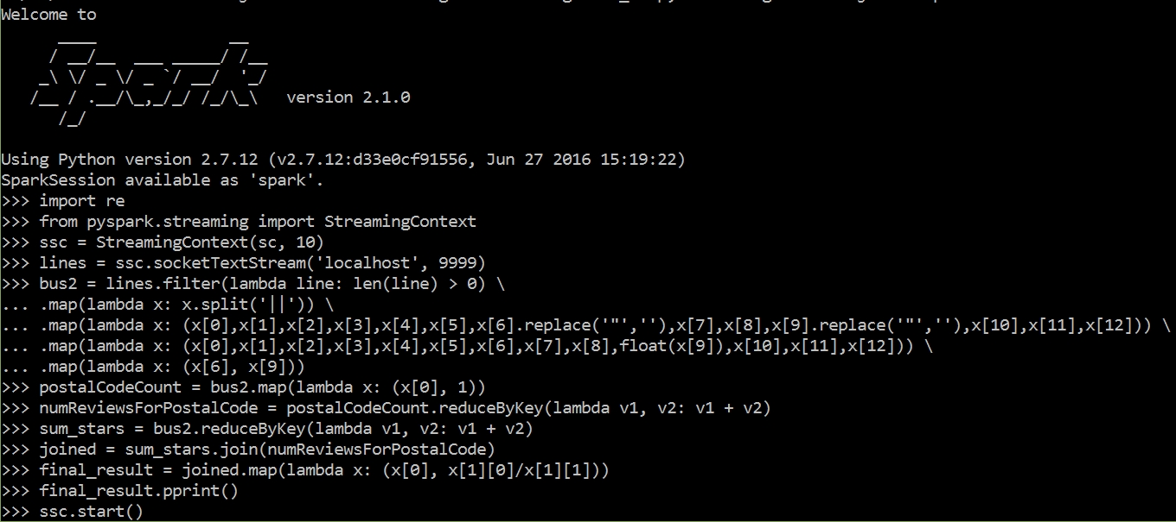

I ran my streaming script from my local Spark installation and not on Databricks. When using local mode, you must specify at least two worker threads. That is what the 2 means in the following command.

**C:\Spark>pyspark --master local[2]**

After entering **ssc.start( )** and pressing enter, I started the flow of input data by opening another command window and entering the script that I mentioned above in the Load Data section. With this data streaming, my script captures lines and performs work on them. The next image is just one of many captured results. As Spark runs the script, the output is very verbose.

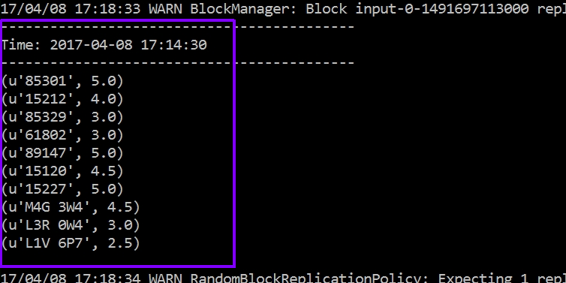

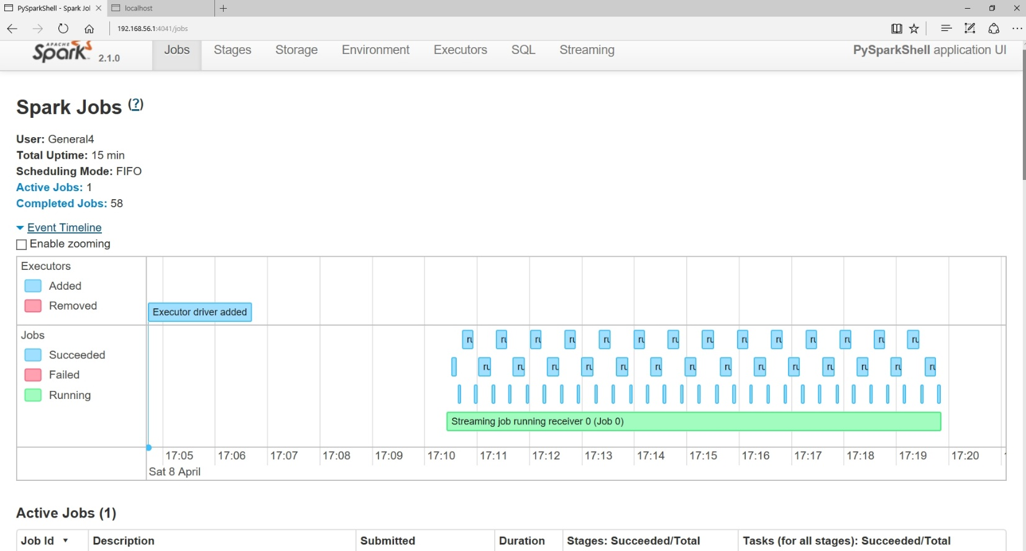

**Update**

The same update information that I mentioned above for Spark batch processing applys for Spark Streaming as well.

**Optimize Quality**

The same quality optimization information that I mentioned above for Spark batch processing applys for Spark Streaming as well.

**Optimize Performance**

As mentioned above, using reduceByKey instead of groupByKey to reduce the amount of data transferred during shuffling applies with Spark streaming as well. I will try to finish this section better on the next assignment, which is all about Spark Streaming. Below is an image from one of the Streaming jobs I ran.

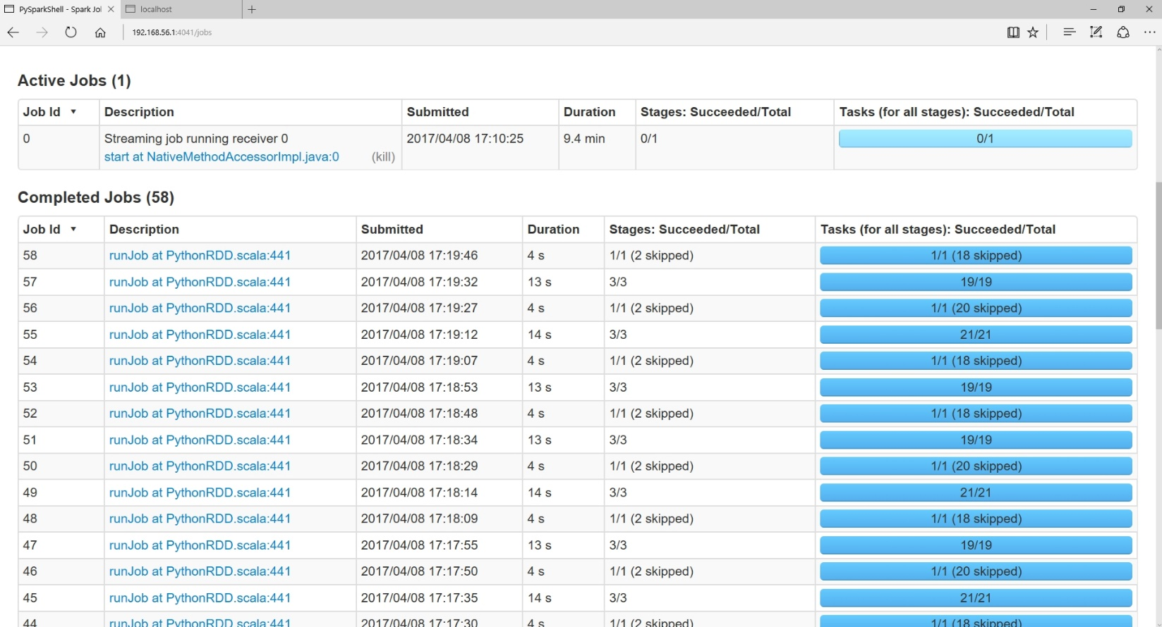

**Spark Summary**

I want to briefly mention how cool I think Spark is. To solve the same problem, my Hadoop MapReduce code took many more lines of code. Additionally, I really enjoy that I can use Python with Spark. It will take a bit more time and practice working with Spark, but I think this is a technology I would love to work with after graduation this Spring. When I took CS152, I saw the power of functional programming but really did not see how it would be used in the real world. Spark showed me how.

# NoSQL with CouchDB

CouchDB is a document based database technology. CouchDB uses a schema-free design and is designed with a focus on data availability and partition tolerance. The moto of CouchDB is Relax. Unfortunately, since I am just learning this technology, it felt like I was working with OuchDB because the process was relatively painful. Since CouchDB is not very mature, there is not a lot of information on the web about it. The documentation on the CouchDB website is not organized very well which caused me to spend more time than I wanted just searching how to do things. However, as I learned, I gained an appreciation for the simplicity of CouchDB.

## Setup

Since I am using a Windows machine, I downloaded the Windows installer from <http://couchdb.apache.org/> . First I tried version 2.0, but because I ran into installation issues, I ended up using version 1.61. Installation was a simple matter of accepting the default options and clicking ‘Next’ in the installer program. After installation, in the Windows list of programs under the start menu, there should be an entry for Apache CouchDB. At this location, there should also be an entry to ‘Start / Stop CouchDB Service’. Click this to start the service. After it starts, you can visit the CouchDB web interface by going to <http://localhost:5984/_utils/index.html> in a web browser.

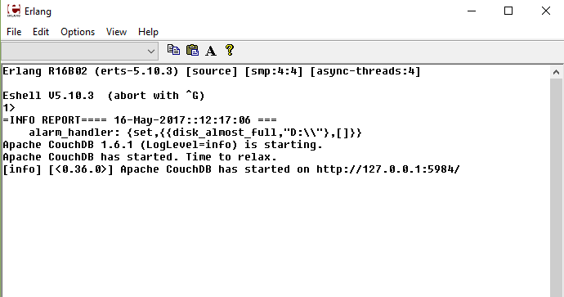

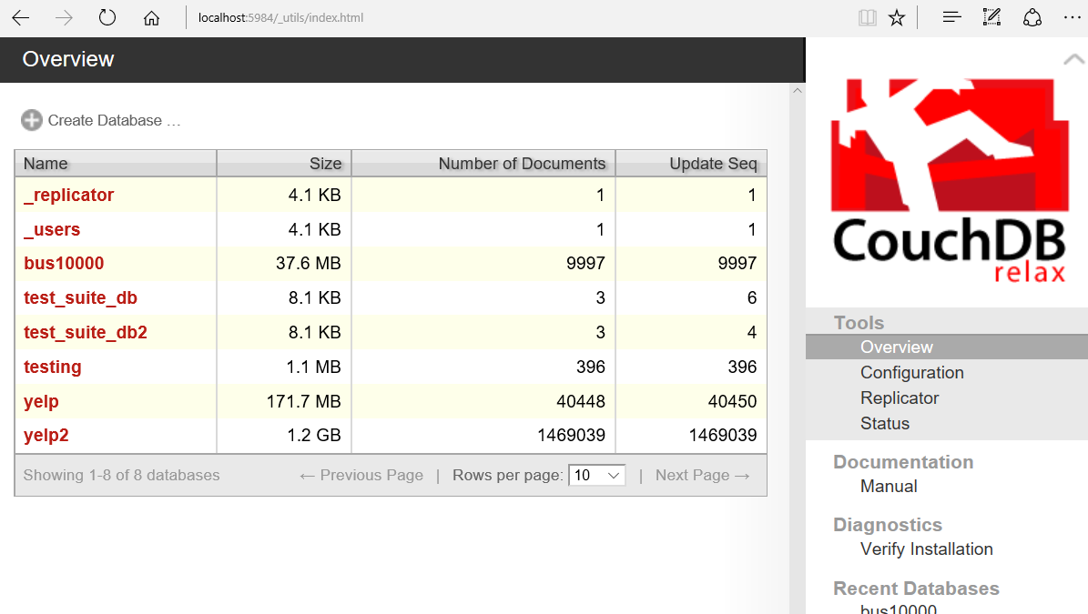

## Database / Schema

Since CouchDB is a schema-less document store, the documents the database work on are scheme-less. However, this does not mean they are structure-less. CouchDB works on JSON files which have structure. Unlike, Hadoop or Spark however, CouchDb does not work with the text files directly. You must import the files into CouchDB. During the import process, CouchDB creates binary database files. Like many databases, CouchDB uses a B-Tree data structure as the foundation of the database.

## ETL

**Extract**

Instead of extracting data from MySQL as I have done in previous assignment, I just used the JSON files given to us in the class folder. These data are mostly well-formed JSON files which is what CouchDB expects. You can not use other file formats with CouchDB.

**Transform**

Since it was mentioned numerous times in class during lecture, I thought it would be cool to use Spark to transform the Yelp data before loading it into CouchDB. Unfortunately, I could not find a CouchDB Spark connector. After more thought, it occurred to me that, even if I did transform the data with Spark, the **saveAsTextFile** function does not save the files in the JSON format that CouchDB expects. However, through research I learned that you can use SparkSQL to read-in JSON files and even save the Data Frames as JSON files. If I had more time, I would consider learning SparkSQL and performing transformations this way.

Transforming data with MySQL is another option. Obviously, using MySQL would not be very fast. I decided against using this option for the same reason I did not use Spark. Even though MySQL has added support to query JSON data, I did not see any documentation on saving in the JSON format. The output files of the transformation need to be well formed JSON data. If it is not, I will need to add another step such as writing a script to parse the files and convert them into JSON. This is something I don’t have time to do. Also, it really wouldn’t make much sense in this context any way. In a similar vein, I could skip using Spark or MySQL and just write a Python script to transform the data. If it’s a CGI script, it could be automated to run daily. The script could query MySQL gathering data and form it into JSON to be delivered to CouchDB. None of these options were going to work for this assignment.

Since CouchDB allows you to use JavaScript to manipulate the data, I decided that it has built-in support to transform data and that I did not need to use another technology. However, before I could transform the data, I need to ingest it into a CouchDB database. This would cause redundant data, but in the world of big data this seems to be normal. Data ingestion will be discussed next in the Load section. And I will discuss more about data transformation in the Query #1 section.

**Load**

As I mentioned above, the documentation for CouchDB is not very good. I initially could not find information on batch loading a set of JSON files into a CouchDB database. Also, when using the CouchDB web interface, there is no upload dialog to import data files. So, my initial data ingestion was less than impressive. I created a database using the CouchDB interface and by using the command line terminal, I wrote a simple script to read lines of the business file and send Curl POST requests to the database. As you can imagine, since this method read each record line-by-line, it was not very fast.

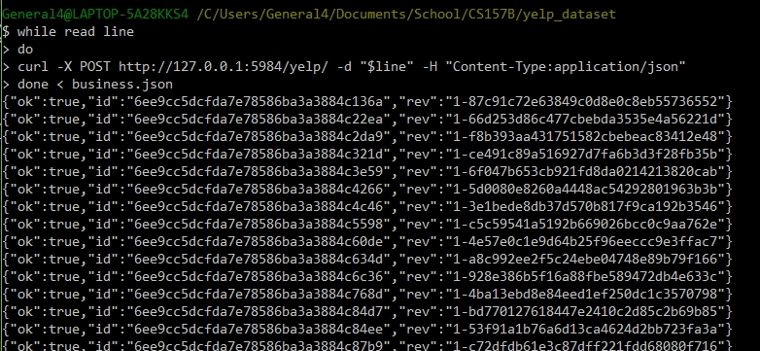

As shown in the screen shot above, CouchDB prepends every record entered into the database with a unique id and revision number. After two and a half hours, only 40,448 records were imported. I aborted the import in search of a better way. Using this method to import all the data would take forever! This method turned out to be a practical exercise on how not to import data.

After talking with a friend, I was informed on how to do bulk data ingestion with CouchDB. He also had a difficult time locating this information. Basically, you do bulk data ingestion very similarly to how I imported data. Two differences to my curl request shown in the screen shot above is – you must append the directory **_bulk_docs** to the path of your database and the script should read in the whole file instead of just a line. However, if the file is too large, the curl POST request can time out. To prevent this, I used a Java program that my friend wrote to chop each Yelp JSON file into many smaller files. Each smaller file contained 10,000 records. For example, after running the program on business.json, the output was 15 files, business0.json – business14.json, each with 10,000 records (except the last file). The whole process only took about 40 minutes – this was a huge improvement. The entire Yelp dataset was put into a single database. My database has no document hierarchy. To extract data from a specific dataset, my queries will use the ‘type’ field that all the documents contain. The value of the type will determine if information is extracted from a particular type.

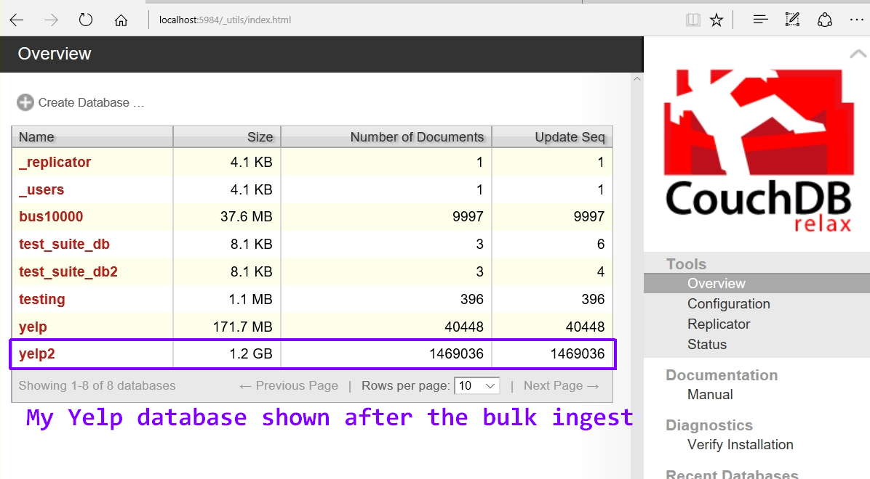

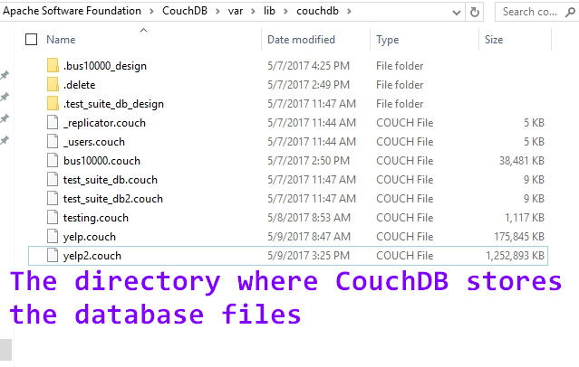

I was impressed with the CouchDB file parser. I know the Yelp data has a lot of data that is not well-formed. Instead of crashing or aborting during ingestion process, CouchDB simply reported when there was bad data and continued with the data ingestion process. This was a refreshing change. With the data finally loaded it was time to try out some querries.

## Queries

**Query #1**

As I mentioned above, CouchDB allows you to use JavaScript to work with the data. You can write map and reduce functions directly in the CouchDB web interface (called Futon) or you could use the command line. To use the web interface, select **Temporary View** from the interface **View** drop-down menu. Then you can enter a map function using JavaScript to filter the data to get only what you need. My first query was very simple, as I was just getting used to the way CouchDB works:

Query: **Select name, review_count From business;**

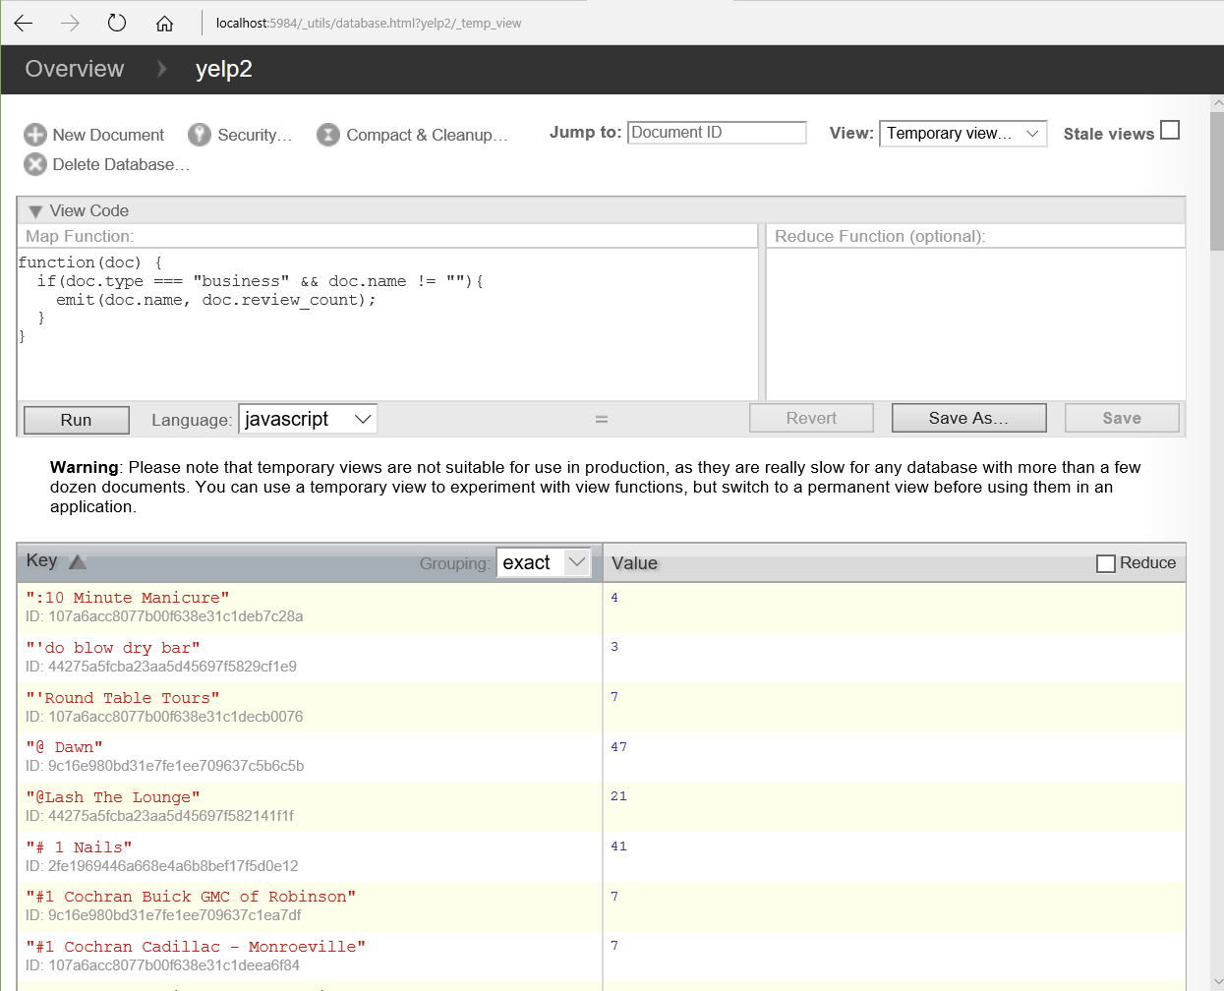

The JavaScript version of this simple query can be seen in the image above. Since CouchDB doesn’t care that some of the documents contain field keys with the same name, you must be specific about which documents you want to extract information from. The *user* dataset contains a field named ‘name’ and another named ‘review_count’, so in my query I need to specify that I only want information pulled from the *business* dataset. I must leverage the **type** field that each document contains. When I first saw the Yelp data, I wondered why each dataset - business, user, etc… - contained a type field. Now I know. In the context of a document store, this field will help select only the documents of a particular type.

**Data Transformation Revisited**

Since the ouput of the map function produced a subset of the business dataset that might prove to be useful for future querries, I decided to save it as a permanent view. This can be considered a transformation of the business data.

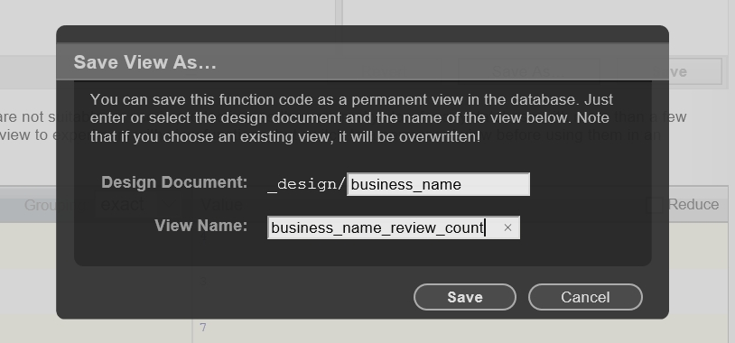

Here is the same info from query #1, but saved as a view. Whenever this information is needed again, it can be pulled up almost instantly since it is permanently stored in the database. Querries that are run against this view will be relatively fast since the whole Yelp dataset is not searched. Views take up disk space, so you don’t want too many of them.

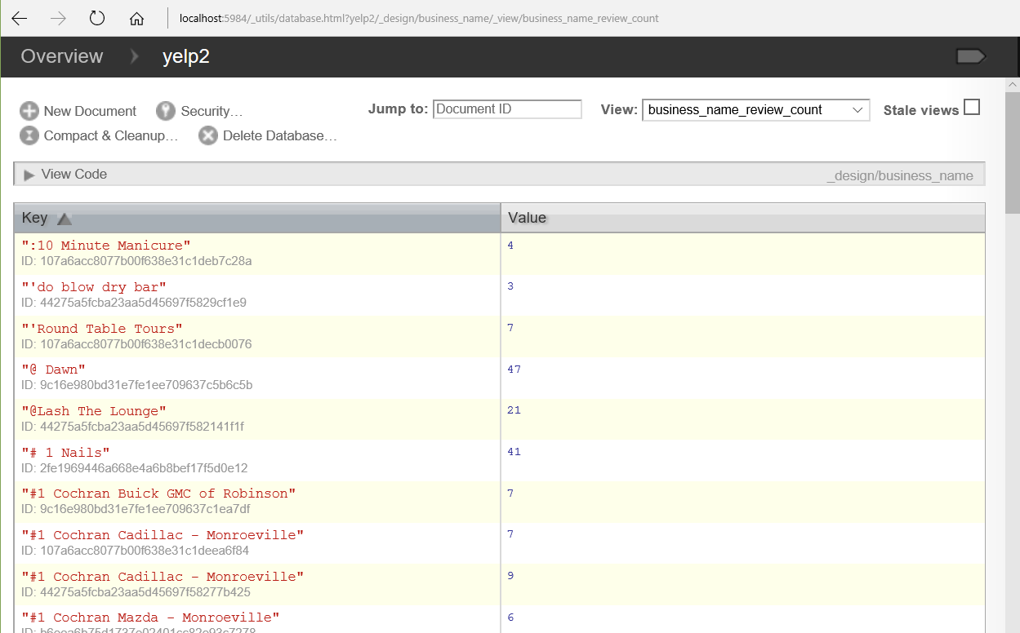

**Query #2**

My second query does the following - for each postal code in Phoenix, find the average star rating for all businesses in that postal code. Here is the MySQL version:

**Select postal_code, Avg(stars)**

**From business**

**Where city = "Phoenix" And postal_code != ""**

**Group By postal_code;**

To solve this query, I use a map function and a reduce function. This is very similar to the way I solved a similar query with Hadoop MapReduce or with Spark. The map function selects all postal codes in phoenix and their corresponding star rating. The reduce function is run once for each distinct postal code. To compute an average, it counts the number of star values for each postal code and also sums each set of star values. It’s nice how my code does not need to do any type casting – like from string to float for instance – CouchDB takes care of this behind the scenes.

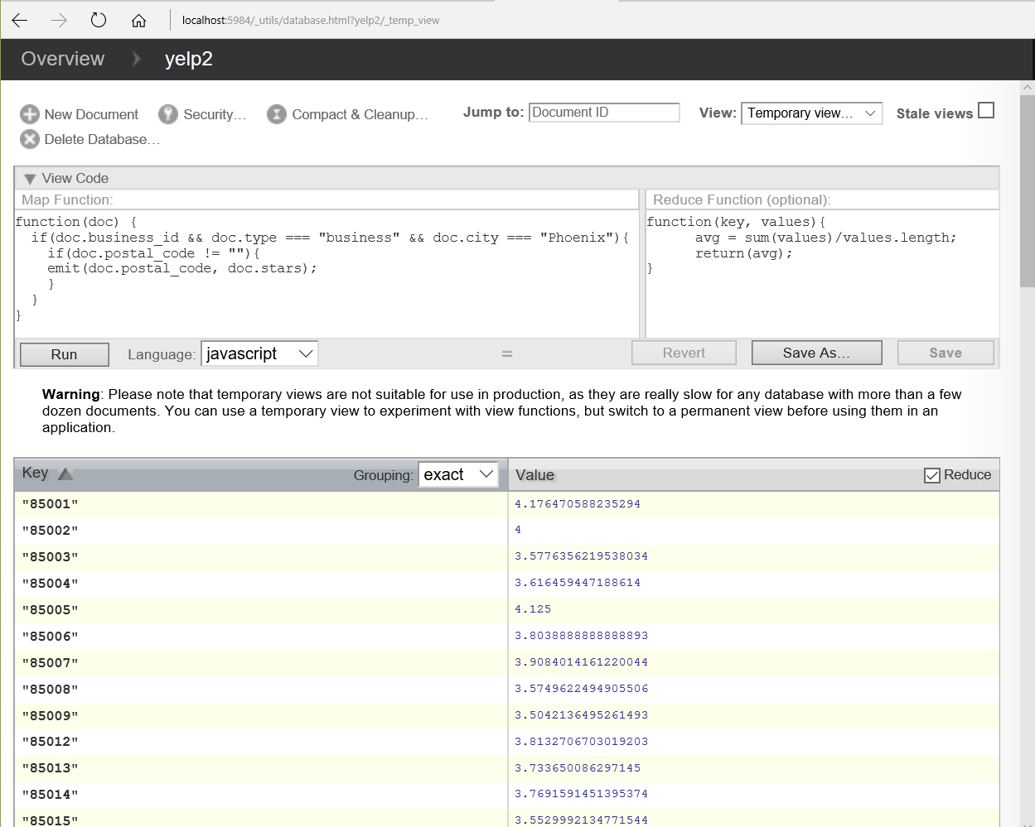

**Query #3**

**Find the count of businesses in Phoenix that share the same name.**

For this query, I created another view first. This view contains the name of Phoenix business as a key and their corresponding review_count and star rating. The query to create this view took 4 minutes and 40 seconds to complete. In the Optimization section below, I will compare the relative differences in query speeds when running queries over a view versus the entire database. The map function will create objects with a business name as a key and an array which contains the review_count and stars as the value. To do the same thing as a Hadoop Map function would have taken much more code. I really like how a little CouchDB code does so much.

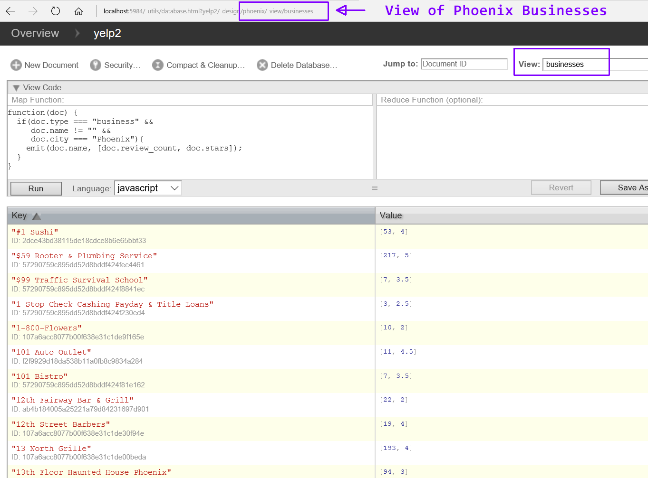

By applying the built-in CouchDB **_count** function as a reducer, I can determine if any businesses share the same name. CouchDB has other built-in reducer functions as well, such as **_sum** and **_stats.**

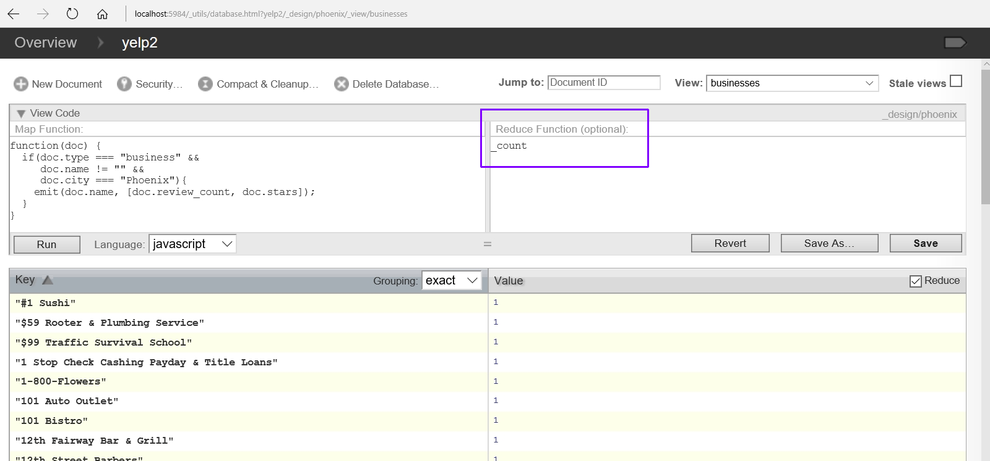

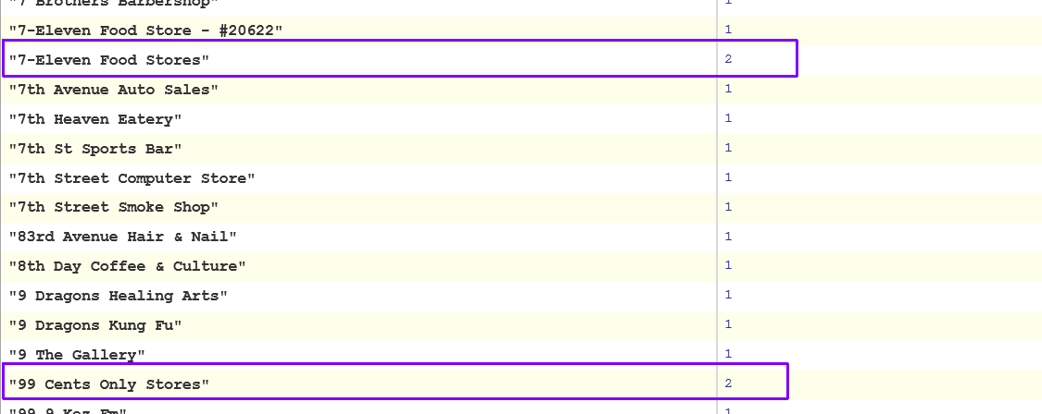

The image above shows some of the businesses in Phoenix that share the same name. These were duplicate keys that were grouped and the count of each group is diplayed.

## Update

To update a document, it is very different than doing an update in MySQL. In MySQL, you tell the data base which record to update and what to update and it just does it. With CouchDB you must retrieve the document you want to update with a GET request, change the part of the document you want updated, and then issue a PUT request to re-write the updated document to the database. In the PUT request, you must specify the current revision number as part of the document or the update will fail. If the update is successful, CouchDB will respond with **ok : true** followed by the document id and a new revision number. In the image below, I updated the **GoodForKids** key from False to True for the document with an id of d9f913332d66beb26da5290bf320a390.

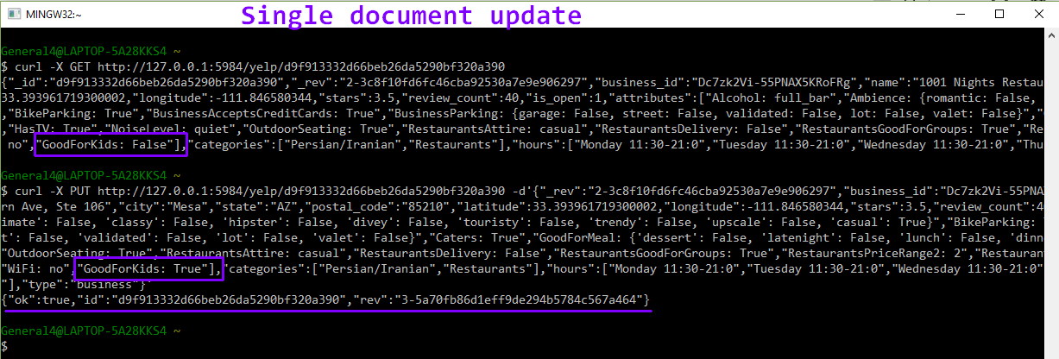

Updating multiple records at one time proved to be very tricky for me. I thought I could use the same process – get what you want to update, update the records, and re-write to database with a Curl GET request, but I kept getting an ‘Invalid JSON’ error message. I’m not sure what I was doing wrong, but I could not dedicate too much time to troubleshoot this.

## Data Quality / Consistency

It is really up to the programmer to ensure data consistency with CouchDB. The database system will not prevent you from entering bad data during an update. As long as it is well formed, JSON it will accept it. So, for instance, CouchDB will not complain if you have a string named ‘crap’ as a value for a key named ‘price’. In MySQL, in such a situation you would likely have an attribute based constraint specifying that price should be a float. This schema-less database design puts more responsibility on the database programmer to ensure data integrity and consistency. This is also true when importing data. Given a large dataset, one could write a program that parses the data before importing it into CouchDB. After this filter process, the data would be clean. However, it’s just as easy to write code that checks the data in the map function. A technology that outputs data in JSON format would be the best fit for CouchDB. I believe SparkSQL could output to the JSON format, so this could be one tool to clean the data. Regular Spark may be able to save in JSON as well, but I am not sure how to do this.

## Performance Optimization

To see how much faster a query is run against a view versus running over all the documents in the database, I ran the map function below against the Phoenix businesses view. This view only contains 7461 records, so I would expect a query run against this view would be much faster than any query run against the whole database.

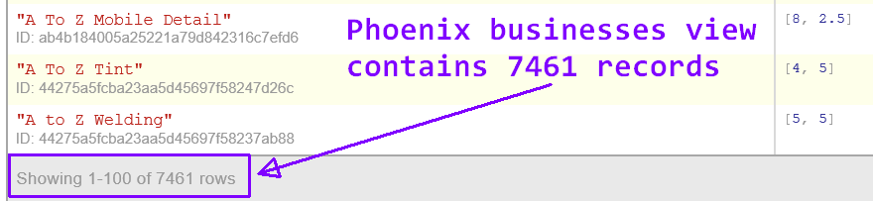

To create the Phoenix businesses view, the query must be run against every record in the database. As noted above in the Query #3 section, it took 4 minutes and 40 seconds to create the view. Since each view in the database is stored in it’s own B-Tree index, I would expect any query run against this view to take much less than this. However, this was not the case. In the query shown in the image below, businesses with the name 1-800-FLOWERS were selected. This query took about the same time as running a query agains the whole database. I am obviously missing something very important. I have no idea why this happened.

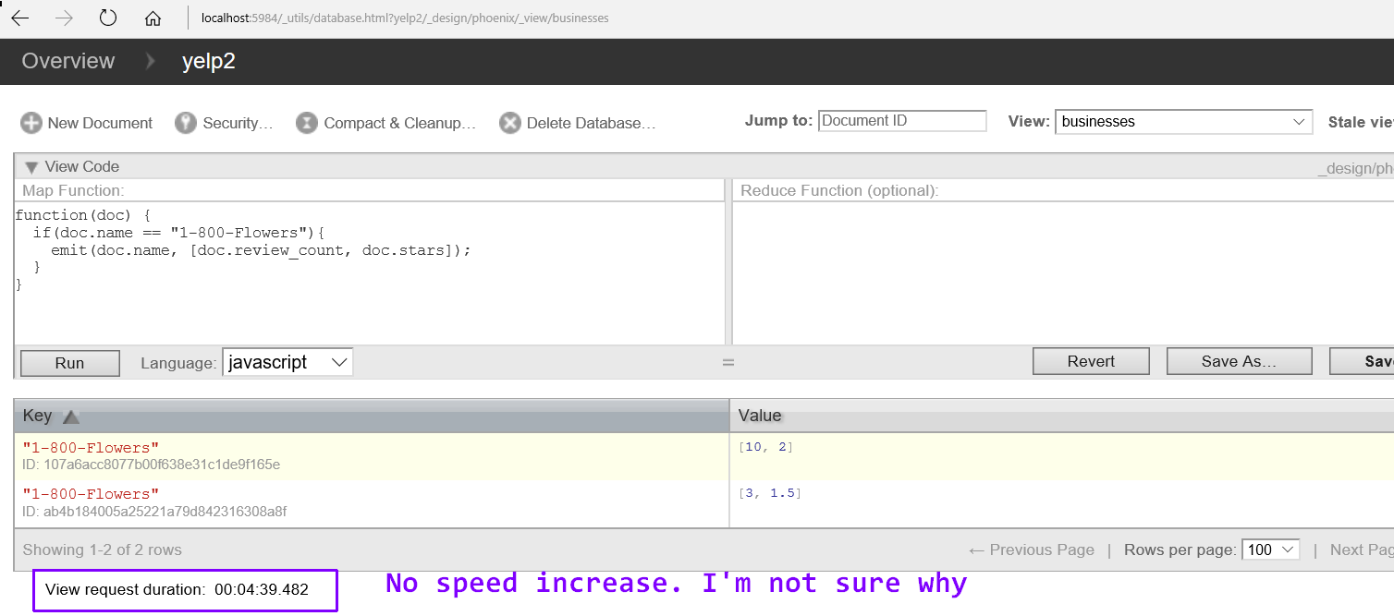

**CouchDB Web Interface or Command Line?**

I could have used the command line more for my queries, but I chose not to because the output was not always well formatted. I did notice though, that the queries ran faster through the command window. The query shown in the image below lists business names. The business documents are the only documents with a key named city, that is why I used that as a filter condition.

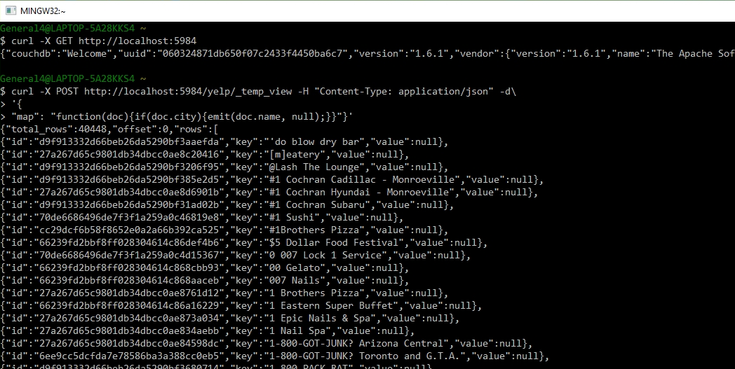

# Technology Comparison

This paper started with MySQL, a relational database that imposes a schema on the data that is imported. MySQL is not flexible – if the data does not match the constraints, it does not get into the database. MySQL is great for OLTP type queries. However, it does not scale well, so when the data gets huge, it is very slow. Analytical queries with MySQL are possible, if the data is not very large. When using MySQL in this way, it is best to save the long running queries as materialized views, so that this data can be accessed faster. A better fit for analytical queries is Hadoop. With Hadoop Map Reduce, you can write analytical queries and take advantage of the parallel processing of the Hadoop system. Hadoop scales out very well. With Hadoop if the data gets twice as big the query will be twice as slow. However, you have the ability to add more clusters to the system and re-gain the speed. I believe a you can do this with MySQL, but putting together a MySQL cluster has disadvantages, like network latency. Hadoop Map Reduce does batch processing. The queries are not expected to be answered in a fraction of a second like a MySQL transactional query. Instead, the results of the batch processing can be saved as a view so that the serving layer of the lambda architecture can access the pre-computed results. Like Hadoop, Spark can do batch processing as well. Additionally, though, Spark can process streaming data. This is the speed layer of the lambda architecture. This is an iterative process where the map and reduce jobs are completed with each iteration. These results can also be saved so that a NoSQL database can access them. A database like CouchDB is the endpoint of the lambda architecture process and is meant to tap into the pre-computed views that both the batch layer and speed layer prepare for it. As mentioned in the sections above, CouchDB is schema-less which requires the programmer to write code to ensure data quality and integrity. Since MySQL imposes a schema on the data on import, any retrieved data will be clean data. Another difference between these databases is that MySQL follows the ACID principle. With MySQL, you can expect consistent data, but with CouchDB, they favor data availability. This is not to say that CouchDB will be totally inconsistent, but that it can be inconsistent more so than MySQL. With CouchDB updates will propagate to all the nodes in the cluster eventually. CouchDB has good built-in support for partition tolerance. So, if some nodes are unavailable, the data can still be accessed on other nodes where the data was replicated. All these data technologies have their strengths and weaknesses. They each have their own place in data processing. All these technologies working together in one system is how big companies use them. Together they are the backbone of Big Data.